**Data Science Project  
Santander Customer Transaction Prediction** by  
Richa Chaturvedi

**Introduction**

**Problem Statement**At Santander, mission is to help people and businesses prosper. We are always looking  
for ways to help our customers understand their financial health and identify which  
products and services might help them achieve their monetary goals.  
Our data science team is continually challenging our machine learning algorithms,  
working with the global data science community to make sure we can more accurately  
identify new ways to solve our most common challenge, binary classification problems  
such as: is a customer satisfied? Will a customer buy this product? Can a customer pay  
this loan? In this challenge, we need to identify which customers will make a specific transaction in the future, irrespective of the amount of money transacted.

**Introduction**

In this project, our task is to build classification models which will be used to predict  
which customers will make a specific transaction in the future. Given below is a sample  
of the Santander customer transaction dataset:

Table 1.1: Train dataset (Columns:1-202)

|  |  |  |  |  |  |  |  |
| --- | --- | --- | --- | --- | --- | --- | --- |
| **ID_code** | **target** | var_0 | var_1 | var_2 | ……… | **……….** | **var_199** |
| **train_01** | 0 | 8.92 | -6.78 | 11.90 | …..... | …….. | -1.09 |
| **train_02** | 0 | 11.5 | -4.14 | 13.85 | ……... | ...…… | 1.95 |
| **train_03** | 0 | 8.60 | -2.74 | 12.08 | ...…… | ...…… | 0.39 |
| **train_04** | 0 | 11.06 | -2.15 | 8.95 | ...…… | ...…… | -8.99 |
| **train_05** | 0 | 9.83 | -1.48 | 12.87 | ...…… | ...…… | -8.81 |

Table 1.2: Test Dataset (Columns: 1-201)

|  |  |  |  |  |  |  |  |
| --- | --- | --- | --- | --- | --- | --- | --- |
| **ID_code** | **var_0** | var_1 | var_2 | var_3 | ……… | **……….** | **var_199** |
| **test_01** | 11.06 | 8.92 | -6.78 | 11.90 | …..... | …….. | -1.09 |
| test_02 | 8.53 | 11.5 | -4.14 | 13.85 | ……... | ...…… | 1.95 |
| **test_03** | 5.48 | 8.60 | -2.74 | 12.08 | ...…… | ...…… | 0.39 |
| test_04 | 8.53 | 11.06 | -2.15 | 8.95 | ...…… | ...…… | -8.99 |
| **test_05** | 11.7 | 9.83 | -1.48 | 12.87 | ...…… | ...…… | -8.81 |

From the table below, we have the following 16 variables, using which we have to  
predict the bike rental count:

Table 1.3: Predictor Variables

|  |  |
| --- | --- |
| SL.No. | Predictor |
| **1** | ID-code |
| 2 | var0 |
| **3** | var1 |
| 4 | var2 |
| **5** | var3 |
| 6 | var4 |
| **7** | var5 |
| .… | .. … |
| ….. |  |
| …. | …… |
| **….** | …… |
| …. | ……. |
| **….** | ……. |
| …. | ……. |
| **….** | …….. |
| 202 | var199 |

* **Software requirement:**

R 3.4.4 for 32 bit

Anaconda 3.4.4.0 for 32 bit

**Data preprocessing:**

When we required to build a predictive model, we require to look and manipulate the data before we start modelling which includes multiple preprocessing steps such as exploring the data, cleaning the data

as well as visualizing the data through graph and plots, all these steps is combined under one shed which is exploratory data analysis, which includes following steps:

• Data exploration and Cleaning

• Missing values analysis

• Outlier Analysis

• Feature Selection

• Features Scaling

Skewness and Log transformation

• Visualization

* **Model Development:**

**Exploratory Data Analysis (EDA)**

Exploratory data analysis is one of the most important steps in data mining in order to  
know features of data. It involves the loading dataset, target classes count, data cleaning,   
typecasting of attributes, missing value analysis, Attributes distributions and trends. So,   
we must clean the data otherwise it will affect on performance of the model. Now we are  
going to explain one by one as follows. In this EDA, I explained with seaborn visualizations.

**Target classes count**

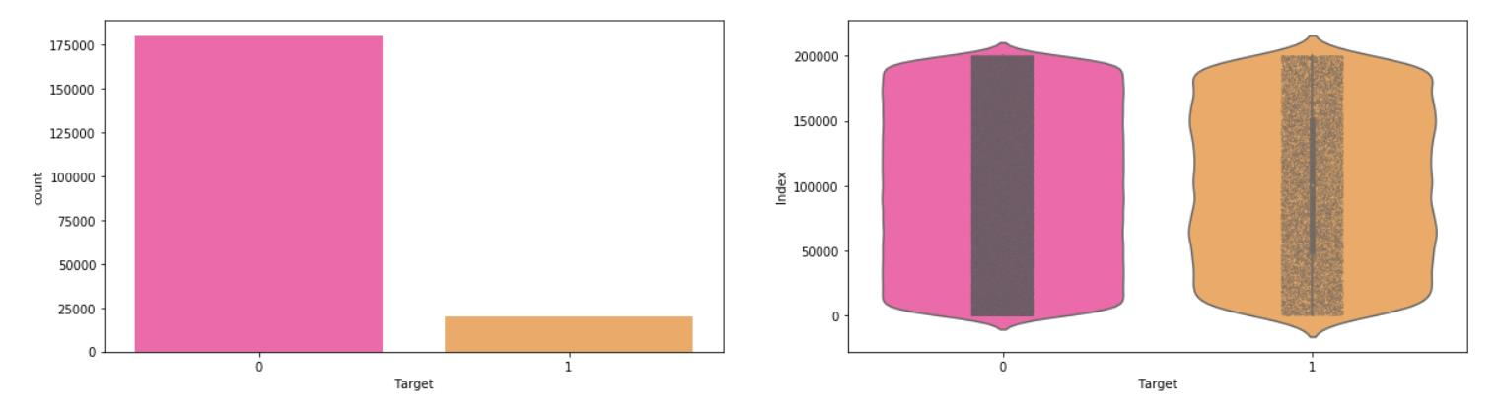

**Observation**:

- We are having a unbalanced data, where 90% of the data is no. of customers who  
 will not make a transaction & 10 % of the data are those who will make a transaction.  
- From the violin plots, it seems that there is no relationship between the target and  
 index of the data frame, it is more dominated by zero compare to one's.  
- From the jitter plots with violin plots, we can observe that target looks uniformly  
 distributed over the indexes of the data frame.

**Missing value Analysis:**

Missing values are created due to human error or faulty survery questions etc. The missing value percentage table is created to determine the amount of missing values with mean values. In this, we have to find out any missing values are present in dataset. If it’s present then either delete or impute the values using mean, median and KNN imputation method. We have not found any missing values in both train and test data.

R and Python code as follows: -

|  |
| --- |
| #R Code:- #Finding the missing values in train data missing_val<-data.frame(missing_val=apply(df_train,2,function(x){s um(is.na(x))})) missing_val<-sum(missing_val) missing_val #Finding the missing values in test data missing_val<-data.frame(missing_val=apply(df_test,2,function(x){su m(is.na(x))})) missing_val<-sum(missing_val) missing_val  #Python Code: - #Finding the missing values in train & test dataset:- train_missing=df_train.isnull().sum().sum() test_missing=df_test.isnull().sum().sum() print('Missing values in train data:',train_missing) print('Missing values in test data:',test_missing) |

* **Attributes distributions and trends Distribution of train attributes:**

Let us look distribution of train attributes from var_0 to var_99

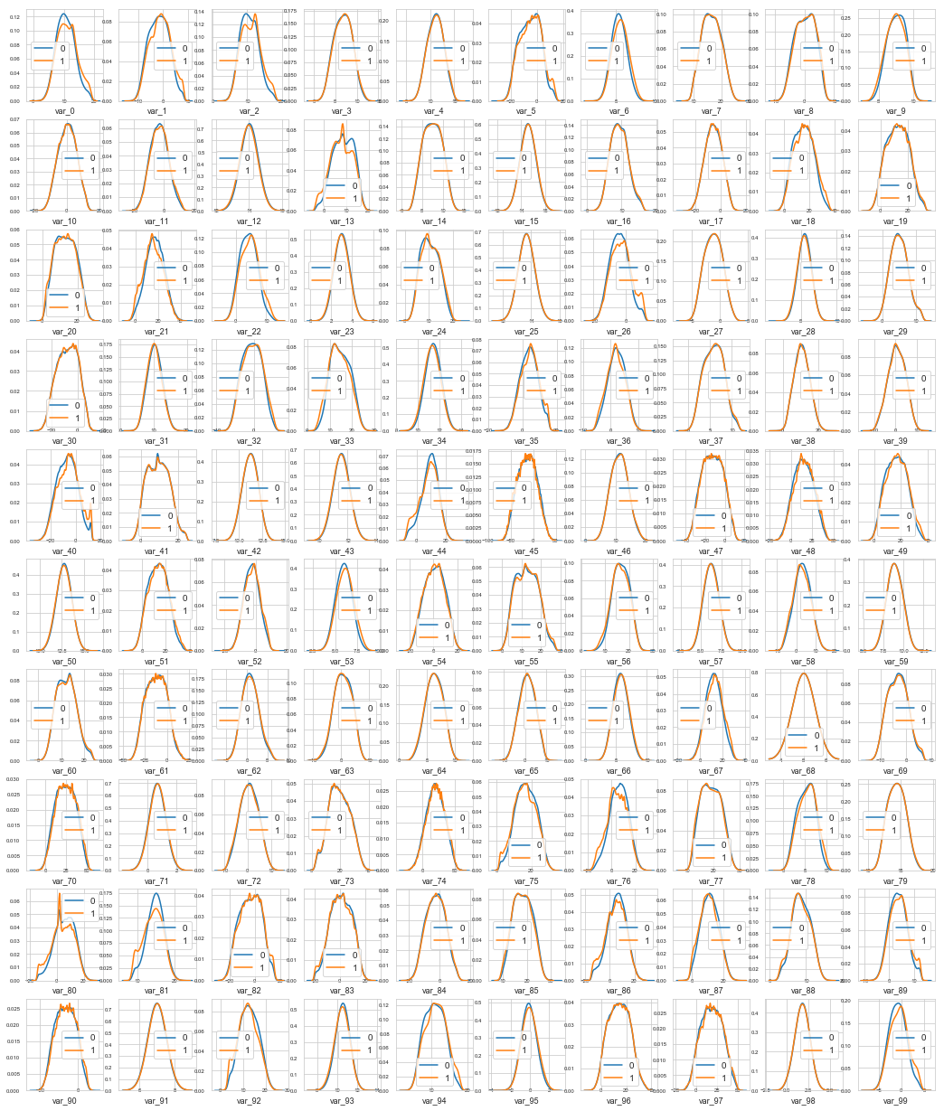

**Observation:**

-We can observed that there is a considerable number of features which are significantly  
have different distributions for two target variables. For example like var_0,var_1,var_9,var_19,var_18 etc.  
- We can observed that there is a considerable number of features which are significantly  
have same distributions for two target variables. For example like var_3,  
var_7,var_10,var_17,var_35 etc.  
  
**Distribution of test attributes:**

Let us look distribution of test attributes from var_0 to var_99

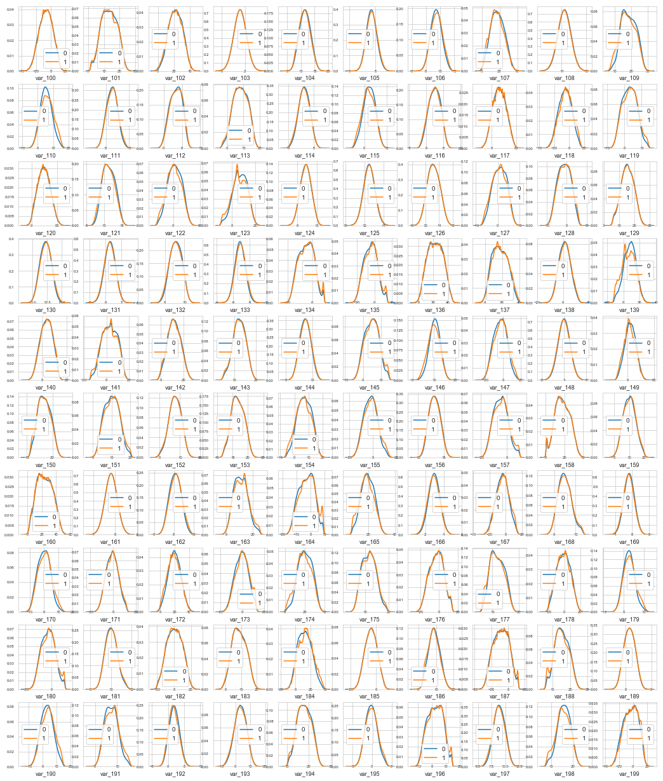

**Distribution of mean values in both train and test dataset:-**Let us look distribution of mean values per column in train and test dataset  
Let us look distribution of mean values per row in train and test dataset:-

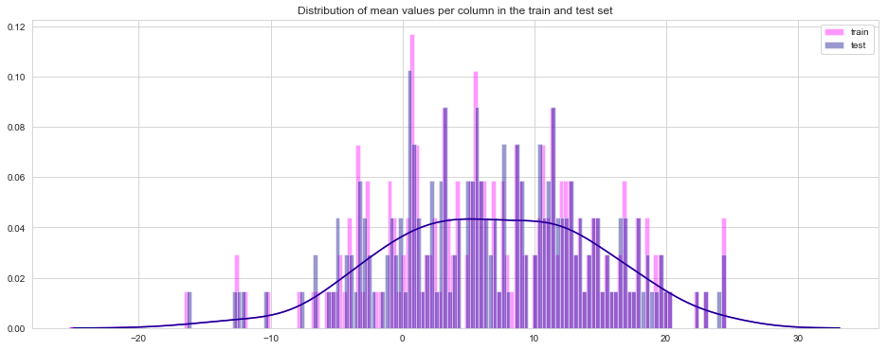

**Distribution of standard deviation (std) values in train and test dataset**Let us look distribution of standard deviation (std) values per column in train and test  
dataset :-  
Let us look distribution of standard deviation (std) values per column in train and test  
dataset

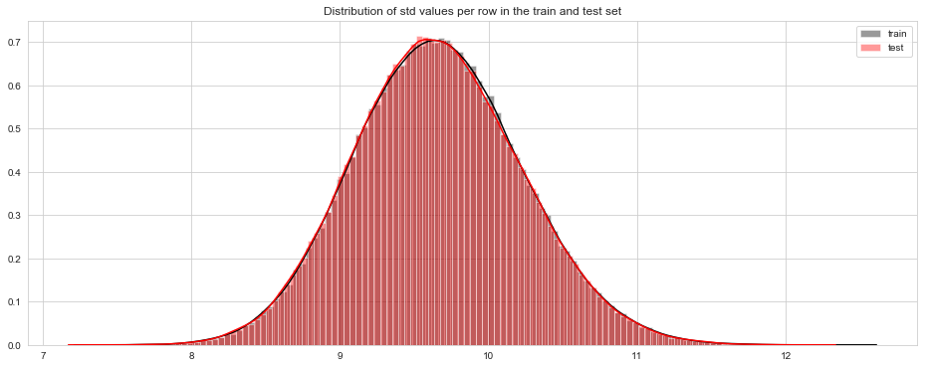

**Distribution of skewness values in train and test dataset**Let us look distribution of skewness values per column in train and test dataset:-  
Let us look distribution of skewness values per column in train and test dataset:-

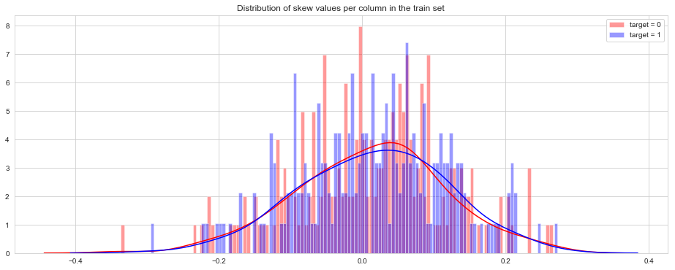  
  
**Distribution of kurtosis values in train and test dataset**Let us look distribution of kurtosis values per column in train and test dataset:-  
Let us look distribution of kurtosis values per row in train and test dataset:-

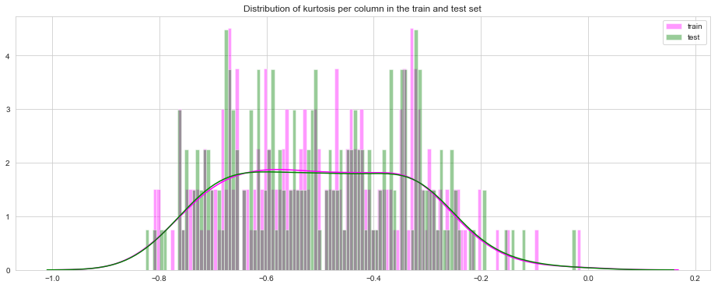

**Outlier analysis**In this project, we haven’t perform outlier analysis due to the data is imbalanced and also  
not required for imbalanced data.

**Feature Selection**Feature selection is very important for modelling the dataset. The every dataset have  
good and unwanted features. The unwanted features would effect on performance of  
model, so we have to delete those features. We have to select best features by using  
ANOVA, Chi-Square test and correlation matrix statistical techniques and so on. In this,  
we are selecting best features by using Correlation matrix. Feature scaling is used to find the collinearity between Manhattan and Euclidean and it shows that the variables Manhattan and Euclidean have multicollinearity. Thus, the variable Euclidean its dropped in R.

**Correlation matrix**:

Correlation matrix, it tells about linear relationship between attributes and help us to  
build better models. From correlation distribution plot, we can observed that correlation between both train and test attributes are very small. It means that all both train and test attributes are independent to each other.

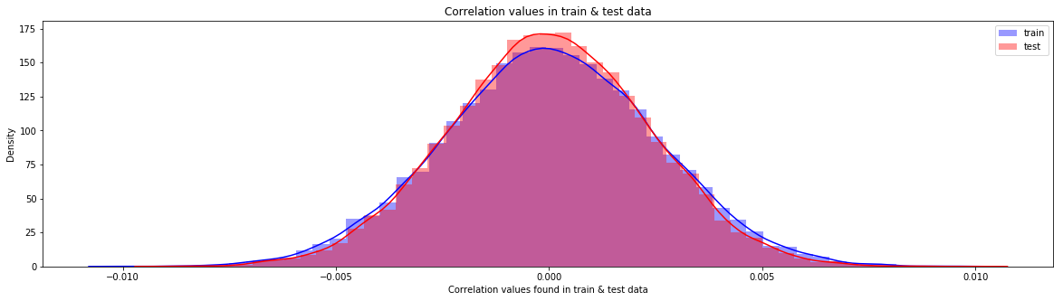

**Feature Scaling:**

Let us do some feature scaling by using  
• Permutation importance  
• Partial dependence plots

**Permutation importance:-**

Permutation variable importance measure in a random forest for classification and  
regression. The variables which are mostly contributed to predict the model.

|  |
| --- |
| **Python code** #Training & testing data: X=df_train.drop(columns=['ID_code','target'],axis=1) test=df_test.drop(columns=['ID_code'],axis=1) y=df_train['target'] #Split the train data:- X_train,X_test,y_train,y_test=train_test_split(X,y,random_state=42)  **Random Forest Classifier:-** %%time rf_model=RandomForestClassifier(n_estimators=10,random_state=42) #fitting the model:- rf_model.fit(X_test,y_test) #Permutation Importance:- from eli5.sklearn import PermutationImportance perm_imp=PermutationImportance(rf_model,random_state=42) |

|  |
| --- |
| #fitting the model:- perm_imp.fit(X_test,y_test) #Important Features:- eli5.show_weights(perm_imp,feature_names=X_test.columns.tolist(),top=200) |

**R code:-**

|  |
| --- |
| #Split the training data using simple random sampling train_index<-sample(1:nrow(df_train),0.75*nrow(df_train)) #train data train_data<-df_train[train_index,] #validation data valid_data<-df_train[-train_index,] #dimension of train and validation data dim(train_data) dim(valid_data) #Random forest classifier:- #Training the Random forest classifier set.seed(2732) #convert to int to factor train_data$target<-as.factor(train_data$target) #setting the mtry mtry<-floor(sqrt(200)) #setting the tunegrid tuneGrid<-expand.grid(.mtry=mtry) #fitting the ranndom forest rf<-randomForest(target~.,train_data[,-c(1)],mtry=mtry,ntree=10,importance=TRUE) |

|  |
| --- |
| #Feature importance by random forest- #Variable importance VarImp<-importance(rf,type=2) VarImp |

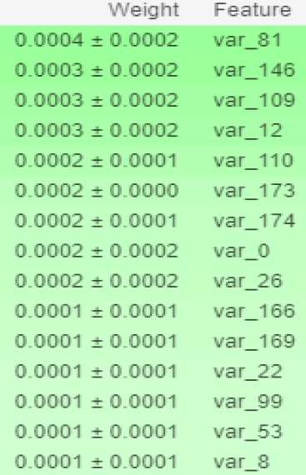

Observation: - We can observed that the top important features are var_12, var_26,  
var_22,v var_174, var_198 and so on based on Mean decrease gini index.

**Partial dependence plots**:

Partial dependence plot gives a graphical depiction of the marginal effect of a variable on  
the class probability or classification. While feature importance shows what variables  
most affect predictions, but partial dependence plots show how a feature affects  
predictions.

|  |
| --- |
| **Python code** #Calculation of partial dependence plots on random forest:- #we are observing impact of main features which are discovered in previous section by using PDP Plot. features=[v for v in X_test.columns if v not in ['ID_code','target']] pdp_data=pdp.pdp_isolate(rf_model, dataset=X_test, model_features=features, feature='var_6') #Plot feature for var_6:- pdp.pdp_plot(pdp_data,'var_6') plt.show() |

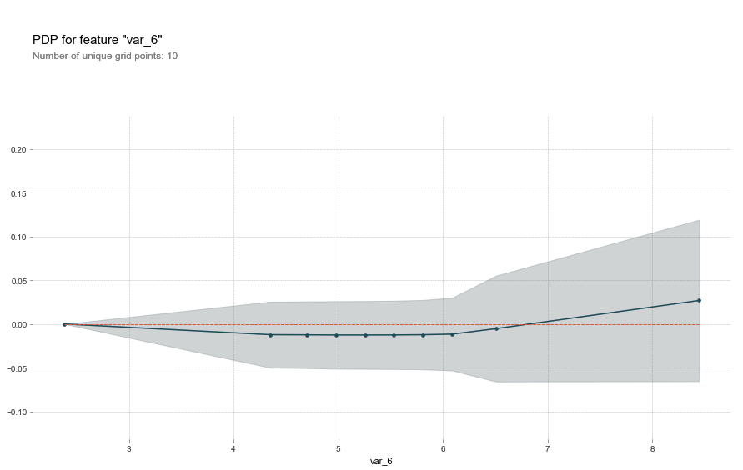

**Observation:**

- The y axis doesn’t show the predictor value instead how the value changing with the  
 change in given predictor variable.  
- The blue shaded area indicates level of confidence of var_6.  
- On y-axis having a positive value means for that particular value of predictor variable  
 its is less likely to predict the correct class & having & having a positive value means  
 it has positive impact on predicting the correct class.

**R Code**:-

|  |
| --- |
| #We will plot "var_6" par.var_6 <- partial(rf, pred.var = c("var_6"), chull = TRUE) plot.var_6 <- autoplot(par.var_6, contour = TRUE) plot.var_6 |

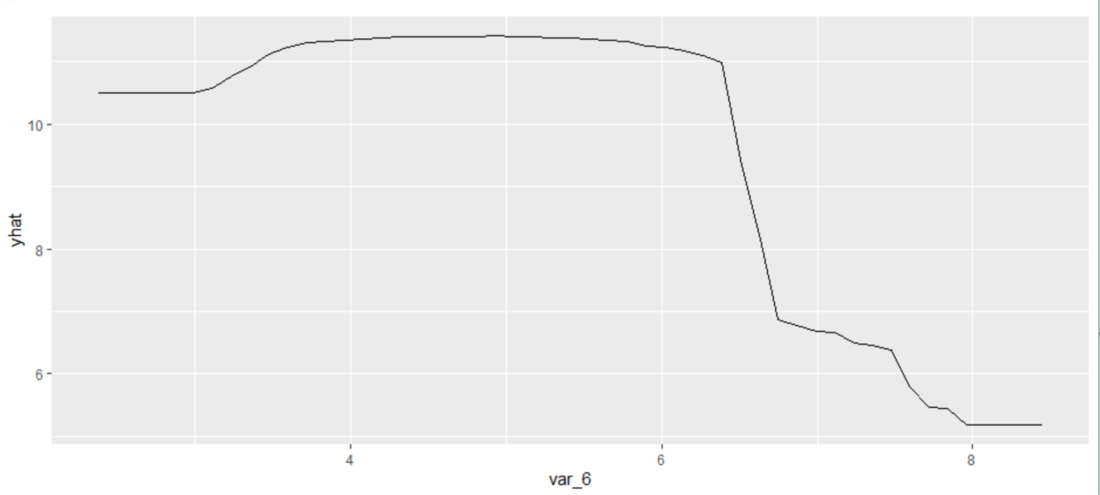

**Modeling:**

**Model Selection:**

After all early stages of preprocessing and then model the data. So, we have to select best  
model for this project with the help of some metrics. The dependent variable can fall in either of the four categories:

1. Nominal  
2. Ordinal  
3. Interval  
4. Ratio

If the dependent variable is Nominal the only predictive analysis that we can perform is  
**Classification**, and if the dependent variable is Interval or Ratio like this project, the  
normal method is to do a **Regression** analysis, or classification after binning.

**Handling of imbalance data**:

Now we are going to explore 5 different approaches for dealing with imbalanced datasets.  
• Change the performance metric  
• Oversample minority class  
• Under sample majority class  
• Synthetic Minority Oversampling Technique (SMOTE) in Python or Random  
Oversampling Examples (ROSE) in R  
• Change the algorithm  
We always start model building from the simplest to more complex.

**Logistic Regression:**

We will use a Logistic Regression to predict the values of our target variable.

|  |
| --- |
| Python Code:- #Spliting the data via Sratified KFold Cross Validator:- #Training Data: X=df_train.drop(['ID_code','target'],axis=1) Y=df_train['target'] #Stratified KFold Cross Validator:- skf=StratifiedKFold(n_splits=5, random_state=42, shuffle=True) for train_index, valid_index in skf.split(X,Y): X_train, X_valid = X.iloc[train_index], X.iloc[valid_index] y_train, y_valid = Y.iloc[train_index], Y.iloc[valid_index] print('Shape of X_train :',X_train.shape) print('Shape of X_valid :',X_valid.shape) print('Shape of y_train :',y_train.shape) print('Shape of y_valid :',y_valid.shape) Logistic Regression Model:- %%time lr_model=LogisticRegression(random_state=42) #fitting the model lr_model.fit(X_train,y_train) #Accuracy of model lr_score=lr_model.score(X_train,y_train) |

|  |
| --- |
| print('Accuracy of lr_model :',lr_score) Accuracy of lr_model : 0.9148942819107381 %%time #Cross validation prediction of lr_model cv_predict=cross_val_predict(lr_model,X_valid,y_valid,cv=5) #Cross validation score cv_score=cross_val_score(lr_model,X_valid,y_valid,cv=5) print('cross val score :',np.average(cv_score)) cross val score : 0.9116728528566072  **R code** Glmnet is a package that fits a generalized linear model via penalized maximum likelihood. #Split the data using CreateDataPartition train.index<-createDataPartition(df_train$target,p=0.8,list=FALSE) train.data<-df_train[train.index,] valid.data<-df_train[-train.index,] #Training dataset X_t<-as.matrix(train.data[,-c(1,2)]) y_t<-as.matrix(train.data$target) #validation dataset X_v<-as.matrix(valid.data[,-c(1,2)]) y_v<-as.matrix(valid.data$target) #test dataset test<-as.matrix(df_test[,-c(1)]) #Logistic regression model set.seed(667) |

|  |
| --- |
| lr_model <-glmnet(X_t,y_t, family = "binomial") summary(lr_model) #Cross validation prediction set.seed(8909) cv_lr <- cv.glmnet(X_t,y_t,family = "binomial", type.measure = "class") #Plotting the missclassification error vs log(lambda) where lambda is regularization parameter #Minimum lambda cv_lr$lambda.min #plot the auc score vs log(lambda) plot(cv_lr) #Model performance on validation dataset set.seed(5363) cv_predict.lr<-predict(cv_lr,X_v,s = "lambda.min", type = "class")  #Confusion matrix set.seed(689) #actual target variable target<-valid.data$target #convert to factor target<-as.factor(target) #predicted target variable #convert to factor cv_predict.lr<-as.factor(cv_predict.lr) confusionMatrix(data=cv_predict.lr,reference=target) #ROC_AUC score and curve set.seed(892) cv_predict.lr<-as.numeric(cv_predict.lr) roc(data=valid.data[,-c(1,2)],response=target,predictor=cv_predict.lr,auc=TRUE, plot=TRUE) |

|  |
| --- |
| #predict the model lr_pred<-predict(lr_model,df_test[,-c(1)],type='class') |

Accuracy of the model is not the best metric to use when evaluating the imbalanced  
datasets as it may be misleading. So, we are going to change the performance metric.

**Oversample Minority Class:-**

-Adding more copies of minority class.  
-It can be a good option we dont have that much large data to work.  
-Drawback of this process is we are adding info. That can lead to overfitting or  
poor performance on test data.

**Undersample Majority class:-**

-Removing some copies of majority class.  
-It can be a good option if we have very large amount of data say in millions to  
work.  
-Drawback of this process is we are removing some valuable info. that can leads  
to underfitting & poor performance on test data.  
As per the drawbacks of both the model we will use SMOTE (Synthetic Minority  
Oversampling technique) that is more best than the above as compare to above one's.

**Synthetic Minority Oversampling Technique (SMOTE)**:

SMOTE uses a nearest neighbor’s algorithm to generate new and synthetic data to use for  
training the model. In order to balance imbalanced data we are going to use SMOTE  
sampling method.

|  |
| --- |
| Python Code:-  %%time from imblearn.over_sampling import SMOTE #SMOTE:- sm = SMOTE(random_state=42, ratio=1.0) #Generating synthetic data points X_smote,y_smote=sm.fit_sample(X_train,y_train) X_smote_v,y_smote_v=sm.fit_sample(X_valid,y_valid)  **Building Logistsic regression model on synthetic data points:-** %%time #Logistic regression model for SMOTE:- smote=LogisticRegression(random_state=42) #fitting the smote model:- smote.fit(X_smote,y_smote) #Accuracy of the model:- smote_score=smote.score(X_smote,y_smote) print('Accuracy of the smote_model :',smote_score) Accuracy of the smote_model : 0.7986096635677659 %%time #Cross validation prediction for SMOTE:- cv_pred=cross_val_predict(smote,X_smote_v,y_smote_v,cv=5) #Cross validation score:- cv_score=cross_val_score(smote,X_smote_v,y_smote_v,cv=5) print('Cross validation score :',np.average(cv_score)) |

Cross validation score : 0.800597554196776

**R code:-  
Random Oversampling Examples (ROSE)**

It creates a sample of synthetic data by enlarging the features space of minority and  
majority class examples. In order to balance imbalanced data we are going to use  
SMOTE sampling method.

|  |
| --- |
| #Random Oversampling Examples(ROSE) set.seed(699) train.rose <- ROSE(target~., data =train.data[,-c(1)],seed=32)$data #target classes in balanced train data table(train.rose$target) valid.rose <- ROSE(target~., data =valid.data[,-c(1)],seed=42)$data #target classes in balanced valid data table(valid.rose$target) #Logistic regression model set.seed(462) lr_rose <-glmnet(as.matrix(train.rose),as.matrix(train.rose$target), family = "binomial") summary(lr_rose) #Cross validation prediction set.seed(473) cv_rose = cv.glmnet(as.matrix(valid.rose),as.matrix(valid.rose$target),family = "binomial", type.measure = "class") cv_rose |

|  |
| --- |
| #Plotting the missclassification error vs log(lambda) where lambda is regularization parameter:- #Minimum lambda cv_rose$lambda.min #plot the auc score vs log(lambda) plot(cv_rose) #Model performance on validation dataset set.seed(442) cv_predict.rose<-predict(cv_rose,as.matrix(valid.rose),s = "lambda.min", type = "class") cv_predict.rose #Confusion matrix set.seed(478) #actual target variable target<-valid.rose$target #convert to factor target<-as.factor(target) #predicted target variable #convert to factor cv_predict.rose<-as.factor(cv_predict.rose) #Confusion matrix confusionMatrix(data=cv_predict.rose,reference=target) |

|  |
| --- |
| #ROC_AUC score and curve:- set.seed(843) #convert to numeric cv_predict.rose<-as.numeric(cv_predict.rose) roc(data=valid.rose[,- c(1,2)],response=target,predictor=cv_predict.rose,auc=TRUE,plot=TRUE) |

**LightGBM:**

LightGBM is a gradient boosting framework that uses tree based learning algorithms. We  
are going to use LightGBM model.

**Python code**

|  |
| --- |
| Let us build LightGBM model #Training data lgb_train=lgb.Dataset(X_train,label=y_train) #Validation data lgb_valid=lgb.Dataset(X_valid,label=y_valid) #Selecting best hyperparameters by tuning of different parameters:- params={'boosting_type': 'gbdt', 'max_depth' : -1, #no limit for max_depth if <0 'objective': 'binary', 'boost_from_average':False, 'nthread': 20, 'metric':'auc', |

|  |
| --- |
| 'num_leaves': 50, 'learning_rate': 0.01, 'max_bin': 100, #default 255 'subsample_for_bin': 100, 'subsample': 1, 'subsample_freq': 1, 'colsample_bytree': 0.8, 'bagging_fraction':0.5, 'bagging_freq':5, 'feature_fraction':0.08, 'min_split_gain': 0.45, #>0 'min_child_weight': 1, 'min_child_samples': 5, 'is_unbalance':True, } #Training lgbm model:- num_rounds=10000 lgbm= lgb.train(params,lgb_train,num_rounds,valid_sets=[lgb_train,lgb_valid],verbose_eval= 1000,early_stopping_rounds = 5000) lgbm Training until validation scores don't improve for 5000 rounds. [1000] training's auc: 0.938996 valid_1's auc: 0.885963 [2000] training's auc: 0.958629 valid_1's auc: 0.890769 [3000] training's auc: 0.972001 valid_1's auc: 0.89195 [4000] training's auc: 0.981625 valid_1's auc: 0.892447 [5000] training's auc: 0.988357 valid_1's auc: 0.892444 |

|  |
| --- |
| [6000] training's auc: 0.992858 valid_1's auc: 0.892633 [7000] training's auc: 0.995834 valid_1's auc: 0.892332 [8000] training's auc: 0.997652 valid_1's auc: 0.89205 [9000] training's auc: 0.99874 valid_1's auc: 0.891803 [10000] training's auc: 0.999366 valid_1's auc: 0.891481 Did not meet early stopping. Best iteration is: [10000] training's auc: 0.999366 valid_1's auc: 0.891481  **R Code:-**  #Convert data frame to matrix set.seed(5432) X_train<-as.matrix(train.data[,-c(1,2)]) y_train<-as.matrix(train.data$target) X_valid<-as.matrix(valid.data[,-c(1,2)]) y_valid<-as.matrix(valid.data$target) test_data<-as.matrix(df_test[,-c(1)]) #training data lgb.train <- lgb.Dataset(data=X_train, label=y_train) #Validation data lgb.valid <- lgb.Dataset(data=X_valid,label=y_valid) #Choosing best hyperparameters #Selecting best hyperparameters set.seed(653) lgb.grid = list(objective = "binary", metric = "auc", boost='gbdt', max_depth=-1, boost_from_average='false', min_sum_hessian_in_leaf = 12, feature_fraction = 0.05, bagging_fraction = 0.45, bagging_freq = 5, learning_rate=0.02, tree_learner='serial', num_leaves=20, num_threads=5, min_data_in_bin=150, |

|  |
| --- |
| min_gain_to_split = 30, min_data_in_leaf = 90, verbosity=-1, is_unbalance = TRUE) #Training the lgbm model set.seed(7663) lgbm.model <- lgb.train(params = lgb.grid, data = lgb.train, nrounds =10000,eval_freq =1 000, valids=list(val1=lgb.train,val2=lgb.valid),early_stopping_rounds = 5000) #lgbm model performance on test data set.seed(6532) lgbm_pred_prob <- predict(lgbm.model,test_data) print(lgbm_pred_prob) #Convert to binary output (1 and 0) with threshold 0.5 lgbm_pred<-ifelse(lgbm_pred_prob>0.5,1,0) print(lgbm_pred) |

**Important features plot  
Python code**

|  |
| --- |
| lgb.plot_importance(lgbm,max_num_features=50,importance_type="split",figsize=(20,50)) |

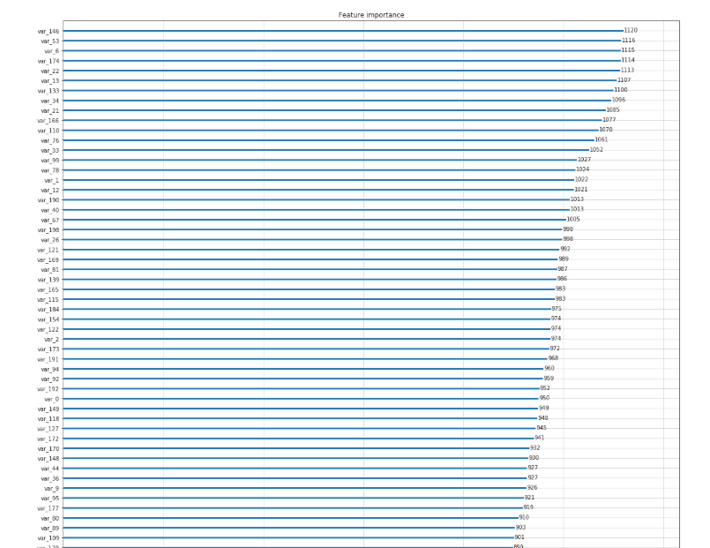  
**R code:**

|  |
| --- |
| tree_imp <- lgb.importance(lgbm.model, percentage = TRUE) lgb.plot.importance(tree_imp, top_n = 50, measure = "Frequency", left_margin = 10) |

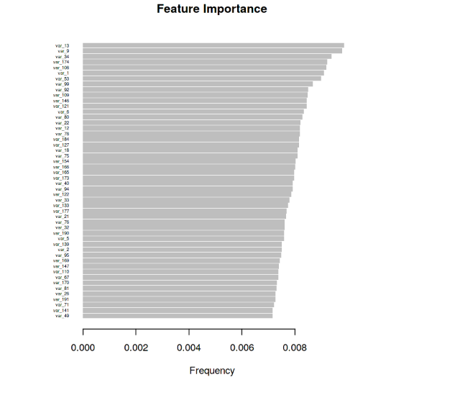

**Model Evaluation:**

Now, we have a four models for predicting the target variable, but we need to decide  
which model better for this project. There are many metrics used for model evaluation.  
Classification accuracy may be misleading if we have an imbalanced dataset or if we  
have more than two classes in dataset. For classification problems, the confusion matrix used for evaluation. But, in our case the data is imbalanced. So, roc_auc_score is used for evaluation.

In this project, we are using two metrics for model evaluation as follows,:

**Confusion Matrix: -** It is a technique for summarizing the performance of a  
classification algorithm.  
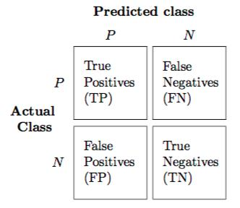

The number of correct predictions and incorrect predictions are summarized with count  
values and broken down by each class.

Accuracy: - The ratio of correct predictions to total predictions  
Accuracy = (𝑇𝑃+𝑇𝑁)/𝑇𝑜𝑡𝑎𝑙 𝑃𝑟𝑒𝑑𝑖𝑐𝑡𝑖𝑜𝑛𝑠  
Misclassification error: - The ratio of incorrect predictions to total predictions  
Error rate = (𝐹𝑁+𝐹𝑃)/𝑇𝑜𝑡𝑎𝑙 𝑝𝑟𝑒𝑑𝑖𝑐𝑡𝑖𝑜𝑛𝑠  
Accuracy=1-Error rate  
True Positive Rate (TPR) = 𝑇𝑃/(𝑇𝑃+𝐹𝑁) ↔ Recall  
Precision = 𝑇𝑃/(𝑇𝑃+𝐹𝑃 )  
True Negative Rate (TNR) = 𝑇𝑁/(𝑇𝑁+𝐹𝑃) ↔ Specificity  
False Positive Rate (FPR) = 𝐹𝑃/(𝐹𝑃+𝑇𝑁 )  
False Negative rate (FNR) = 𝐹𝑁/(𝐹𝑁+𝑇𝑃 )  
F1 score :- Harmonic mean of precision and recall, used to indicate balance between  
them.  
  
F1 score = 2∗𝑃𝑟𝑒𝑐𝑖𝑠𝑖𝑜𝑛∗𝑅𝑒𝑐𝑎𝑙𝑙𝑃𝑟𝑒𝑐𝑖𝑠𝑖𝑜𝑛+𝑅𝑒𝑐𝑎𝑙𝑙

**Receiver operating characteristics (ROC)_Area under curve(AUC) Score roc_auc_score** :- It is a metric that computes the area under the Roc curve and also used metric for imbalanced data. Roc curve is plotted true positive rate or Recall on y axis against false positive rate or specificity on x axis. The larger the area under the roc curve better the performance of the model.

**Logistic Regression:**

Logistic model is used to model the probability of a certain class or event existing such as pass/fail, win/lose, alive/dead or healthy/sick. This can be extended to model several classes of events such as determining whether an image contains a cat, dog, lion. It is a classification algorithm used to predict the binary outcomes for a given set of independent variables. The dependent variable’s outcome is discrete.

#Confusion matrix:

|  |
| --- |
| cm=confusion_matrix(y_valid,cv_predict) cm=pd.crosstab(y_valid,cv_predict) cm |

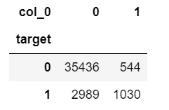

#ROC_AUC_Curve:-

|  |
| --- |
| plt.figure() false_positive_rate,recall,thresholds=roc_curve(y_valid,cv_predict) roc_auc=auc(false_positive_rate,recall) plt.title('Reciver Operating Characteristics(ROC)') plt.plot(false_positive_rate,recall,'b',label='ROC(area=%0.3f)' %roc_auc) plt.legend() |

|  |
| --- |
| plt.plot([0,1],[0,1],'r--') plt.xlim([0.0,1.0]) plt.ylim([0.0,1.0]) plt.ylabel('Recall(True Positive Rate)') plt.xlabel('False Positive Rate') plt.show() print('AUC:',roc_auc) |

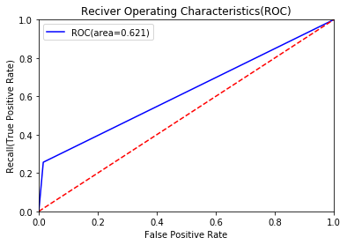

When we compare the roc_auc_score and cross validation score, conclude that model is  
not performing well on imbalanced data.  
  
**Classification report**

We can observed that f1 score is high for number of customers those who will not make a  
transaction then who will make a transaction. So, we are going to change the algorithm.

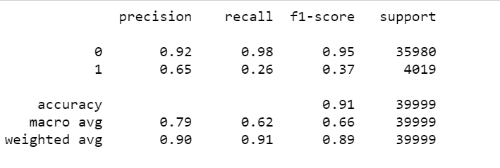

**R code  
Logistic Regression**

#Cross validation prediction

|  |
| --- |
| set.seed(8909) cv_lr <- cv.glmnet(X_t,y_t,family = "binomial", type.measure = "class") cv_lr #Plotting the missclassification error vs log(lambda) where lambda is regularization parameter #Minimum lambda cv_lr$lambda.min #plot the auc score vs log(lambda) plot(cv_lr) |

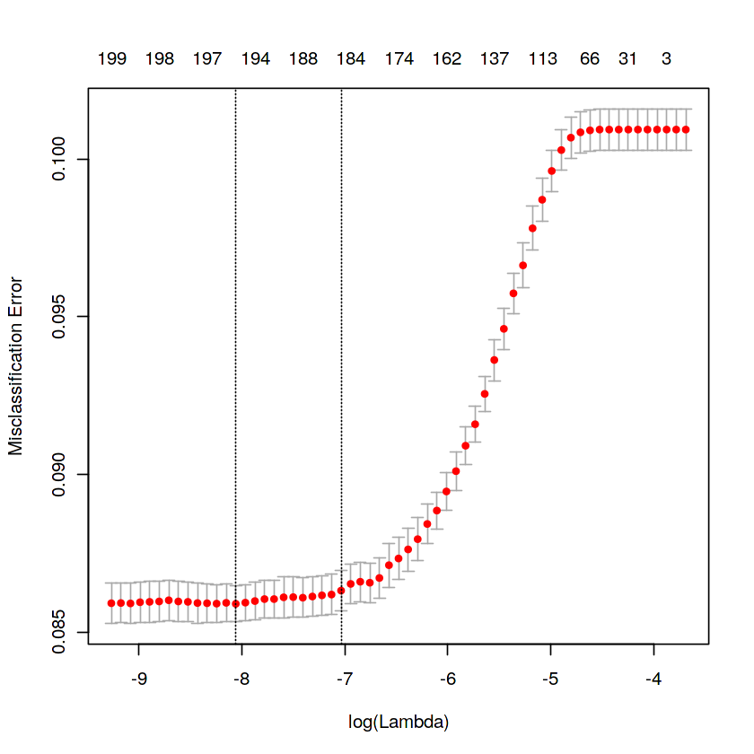  
We can observed that miss classification error increases as increasing the log(Lambda).

|  |
| --- |
| #Confusion Matrix:- set.seed(689) #actual target variable target<-valid.data$target #convert to factor target<-as.factor(target) |

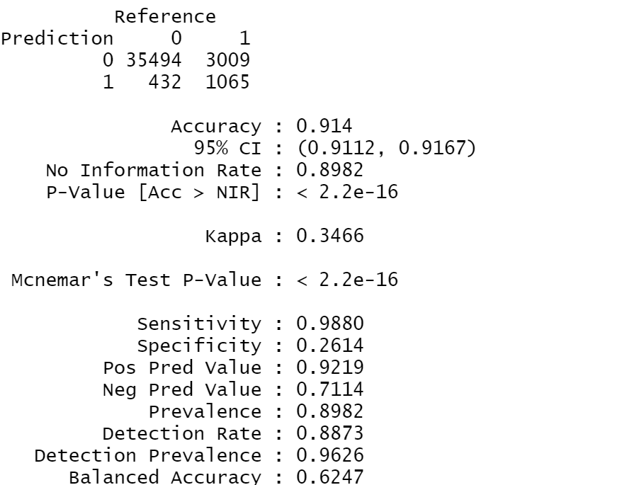

|  |
| --- |
| #predicted target variable #convert to factor cv_predict.lr<-as.factor(cv_predict.lr) confusionMatrix(data=cv_predict.lr,reference=target) |

**Reciever operating characteristics(ROC)-Area under curve(AUC) score and curve:**

#ROC_AUC score and curveset.seed(892)  
cv_predict.lr<-as.numeric(cv_predict.lr)  
roc(data=valid.data[,-  
c(1,2)],response=target,predictor=cv_predict.lr,auc=TRUE,plot=TRUE) 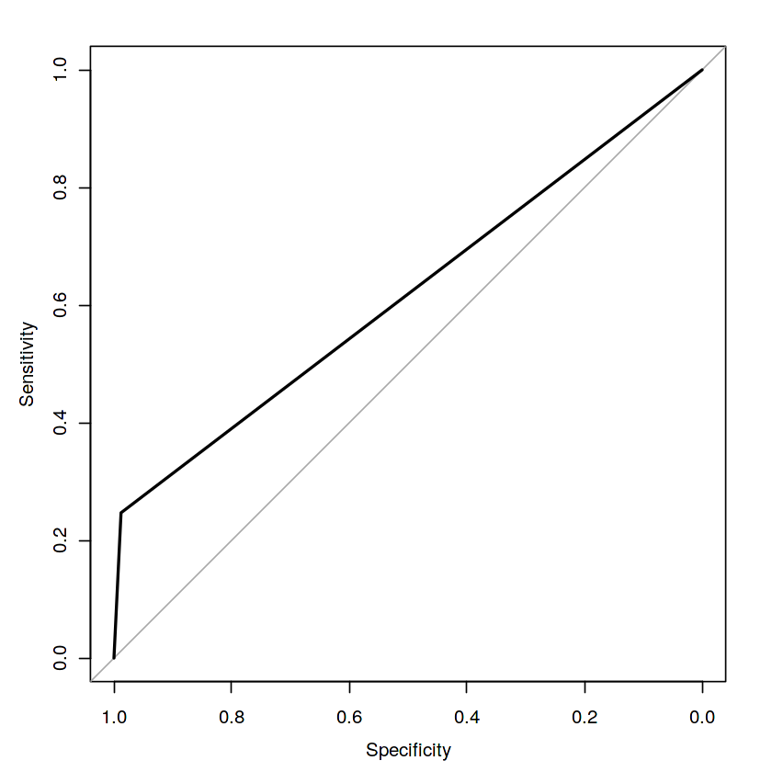

**Python code  
Synthetic Minority Oversampling Technique (SMOTE)**

|  |
| --- |
| %%time #Confusion matrix:- cm=confusion_matrix(y_smote_v,cv_pred) cm=pd.crosstab(y_smote_v,cv_pred) |

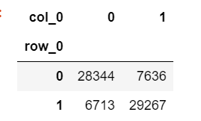

**Reciever operating characteristics (ROC)-Area under curve (AUC) score and curve**

|  |
| --- |
| #ROC_AUC Curve:- plt.figure() false_positive_rate,recall,thresholds=roc_curve(y_smote_v,cv_pred) roc_auc=auc(false_positive_rate,recall) plt.title('Reciver Operating Characteristics(ROC)') plt.plot(false_positive_rate,recall,'b',label='ROC(area=%0.3f)' %roc_auc) plt.legend() plt.plot([0,1],[0,1],'r--') plt.xlim([0.0,1.0]) plt.ylim([0.0,1.0]) plt.ylabel('Recall(True Positive Rate)') plt.xlabel('False Positive Rate') plt.show() |

|  |
| --- |
| print('AUC:',roc_auc) |
|  |

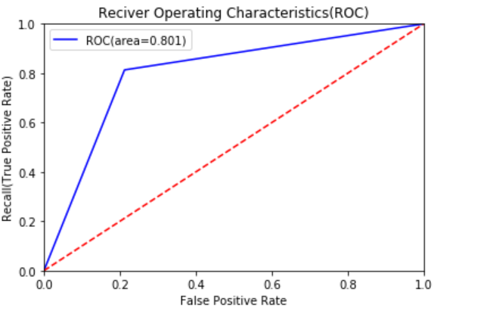

**Classification report**#Classification Report:-  
scores=classification_report(y_smote_v,cv_pred)  
print(scores)

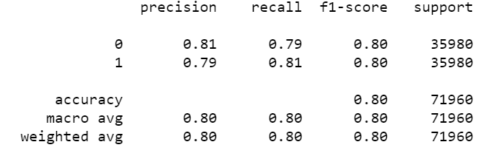

We can observed that smote model is performing well on imbalance data compare to  
baseline logistic regression.

**R code  
Random Oversampling Examples (ROSE)**

#Plotting the missclassification error vs log(lambda) where lambda is regularization  
parameter:-  
#Minimum lambda  
cv_rose$lambda.min  
#plot the auc score vs log(lambda)  
plot(cv_rose)

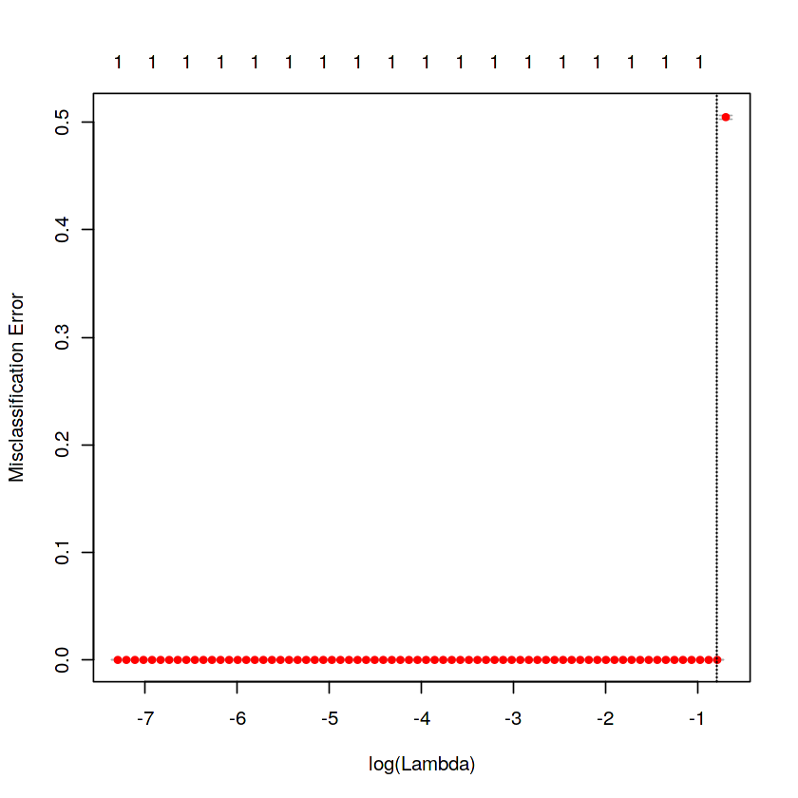

#Confusion matrix

|  |
| --- |
| set.seed(478) #actual target variable target<-valid.rose$target #convert to factor target<-as.factor(target) #predicted target variable #convert to factor cv_predict.rose<-as.factor(cv_predict.rose) #Confusion matrix confusionMatrix(data=cv_predict.rose,reference=target) |

**Reciever operating characteristics (ROC)-Area under curve(AUC) score and curve**

|  |
| --- |
| #ROC_AUC score and curve set.seed(843) #convert to numeric cv_predict.rose<-as.numeric(cv_predict.rose) roc(data=valid.rose[,- c(1,2)],response=target,predictor=cv_predict.rose,auc=TRUE,plot=TRUE) |

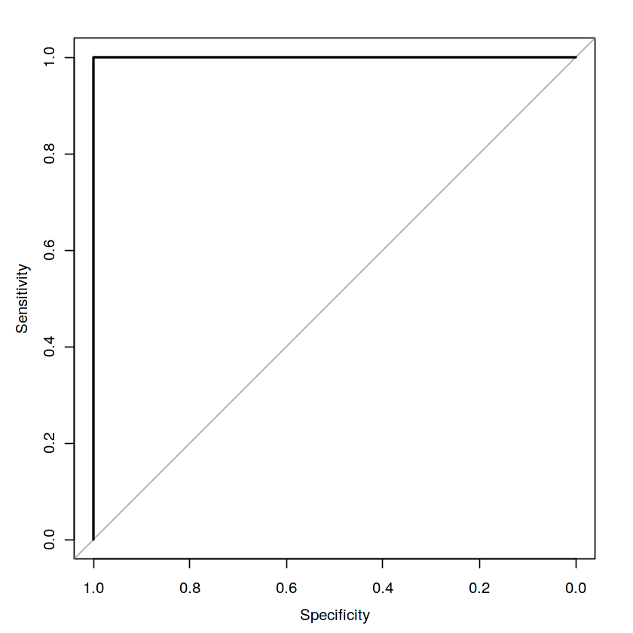

I tried different ways to get good accuracy like changing count of one target class  
variable. Finally got area under ROC curve is 1 but this may not be possible.

**Decision Trees:**

A tree has many analogies in real life, and turns out that it has influenced a wide area of machine learning, covering both classification and regression. In decision analysis, a decision tree can be used to visually and explicitly represent decisions and decision making. As the name goes, it uses a tree-like model of decisions. It is a predictive modeling based on branching series of Boolean test.

**Random Forest**:

Random forests or random decision forests are an ensemble learning method for classification, regression and other task, that operate by constructing a multitude of decision trees at training time and outputting the class that is the mode of the classes (classification) or mean prediction (regression) of the individual trees. Random decision forests correct for decision trees' habit of overfitting to their training set.

**To say it in simple words: Random forest builds multiple decision trees and merges them together to get a more accurate and stable prediction.**

* **Gradiant Boosting**:

Light Gradient boosting is a machine learning technique for regression and classification problems, which produces a prediction model in the form of an ensemble of weak prediction models, typically decision trees. It builds the model in a stage-wise fashion like other boosting methods do, and it generalizes them by allowing optimization of an arbitrary differentiable loss function.

LightGBM is a gradient boosting framework that uses tree based learning algorithms. It is designed to be distributed and efficient with the following advantages: Support of parallel and GPU learning and capable of handling large-scale data.

**Model Selection:**When we compare scores of area under the ROC curve of all the models for an  
imbalanced data. We could conclude that below points as follow:

**Model Evaluation:**

The main concept of looking at what is called residuals or difference between our predictions f(x[I,]) and actual outcomes y[i].

In general, most data scientists use two methods to evaluate the performance of the model:

I. **RMSE (Root Mean Square Error):** It is a frequently used measure of the difference between values predicted by a model and the values actually observed from the environment that is being modelled.

*RMSE* = ∑*in*=1(*Xobs*,*i* – *Xmodel,i)2/n*

**2. R Squared(R^2):** Itis a statistical measure of how close the data are to the fitted  
regression line. It is also known as the coefficient of determination, or the coefficient  
of multiple determination for multiple regression. In other words, we can say it  
explains as to how much of the variance of the target variable is explained. We have shown both train and test data results, the main reason behind showing both  
the results is to check whether our data is overfitted or not.

|  |  |  |
| --- | --- | --- |
| **Model Name** | **RMSE** | **R Squared** |
| **Train** | **Test** | **Train** | **Test** |
| `Logistic Regression | 0.27 | 0.25 | 0.60 | 0.77 |
| Decision Tree | 0.30 | 0.28 | 0.65 | 0.70 |
| Random Forest model | 0.09 | 0.23 | 0.64 | 0.79 |
| Light Graient Boosting | 0.22 | 0.22 | 0.85 | 0.81 |

1. Logistic regression model, decision tree and randon forest didnot not performed well on imbalanced data.  
2. We balance the imbalanced data using resampling techniques like SMOTE in python  
and ROSE in R.  
3. Baseline logistic regression model is performed well on balanced data.  
4. LightGBM model performed well on imbalanced data.

Finally LightGBM is best choice for identifying which customers will make a specific  
transaction in the future, irrespective of the amount of money transacted.

**Diagrams:**

**ggplot2 visualizations**

**Target classes count**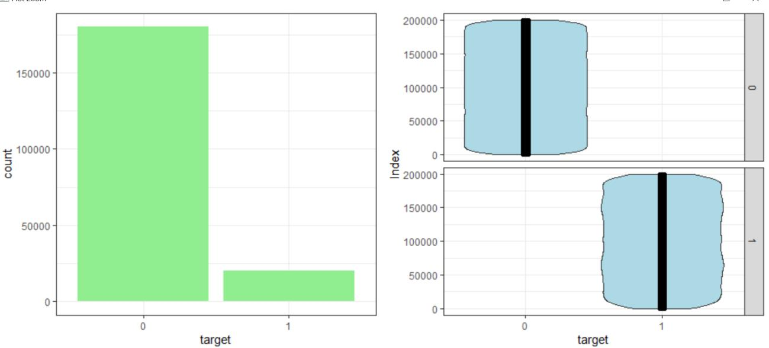

**Distribution of train attributes**  
  
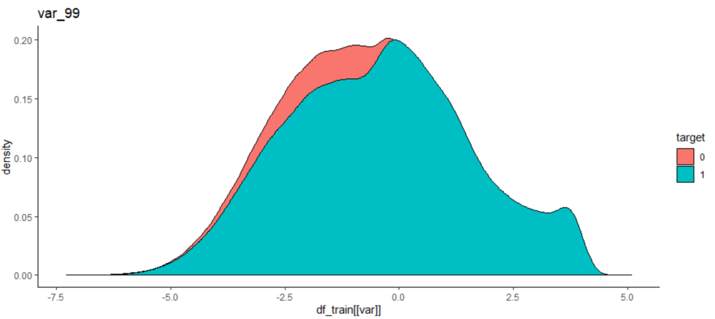

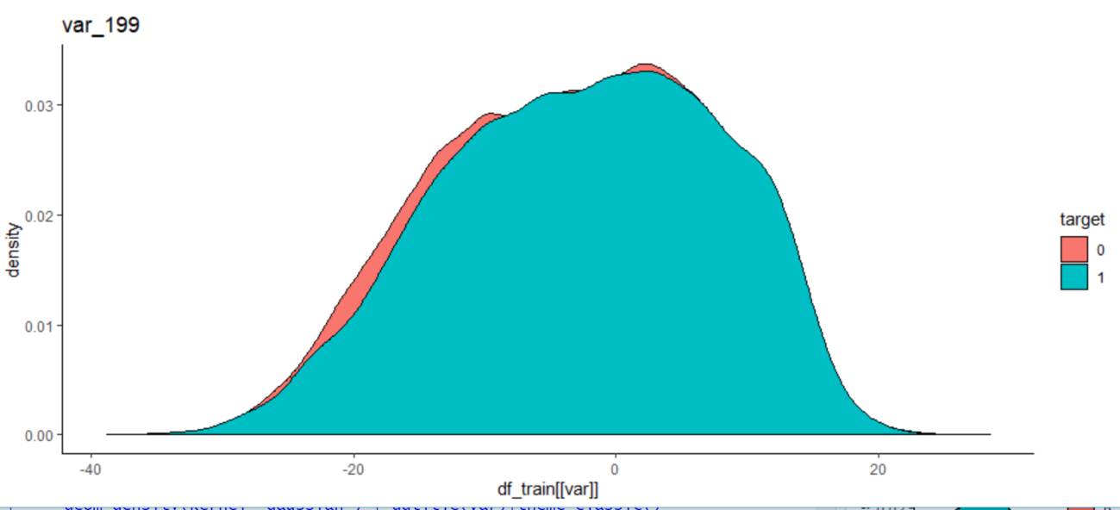

**Distribution of test attributes**

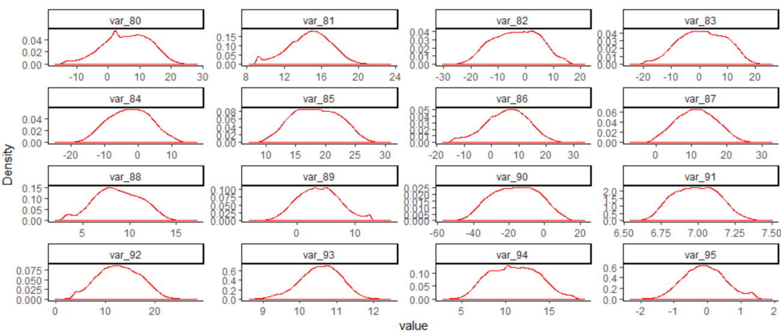

**Distribution of mean values per row in train & test data**

**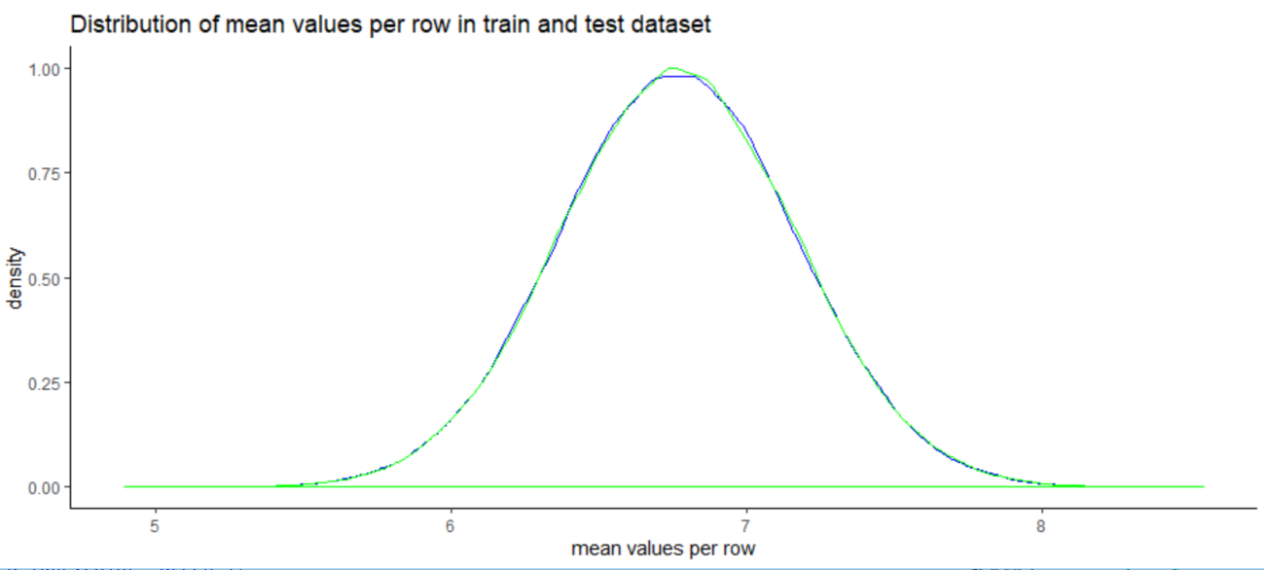  
Distribution of mean values per columns in train & test data**  
 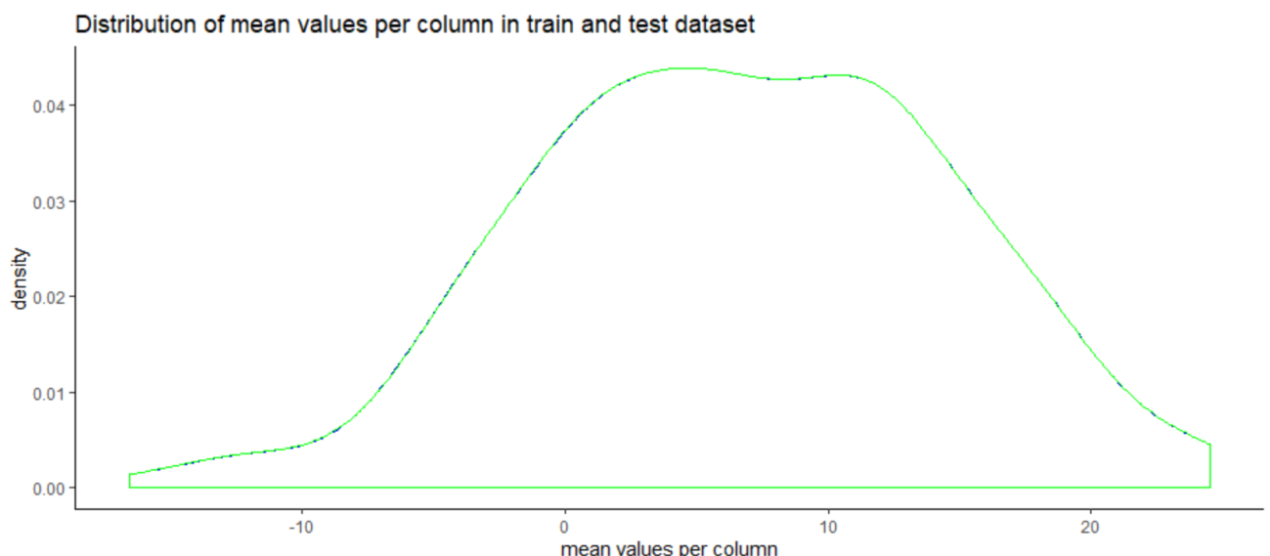

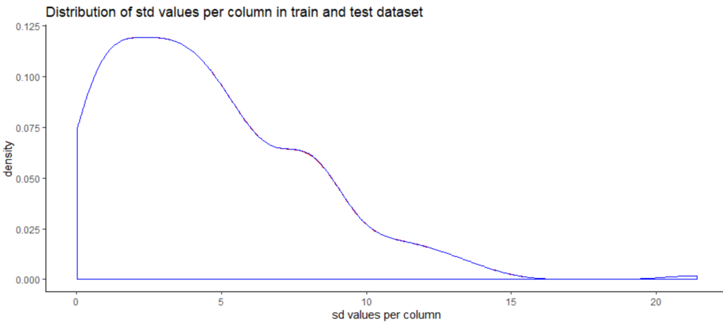

Skewness and Log transformation:

Skewness is asymmetry in a statistical distribution, in which the curve appears distorted or skewed either to the left or to the right. Skewness can be quantified to define the extent to which a distribution differs from a normal distribution. Below mentioned graphs shows the probability distribution plot to check distribution before log transformation:

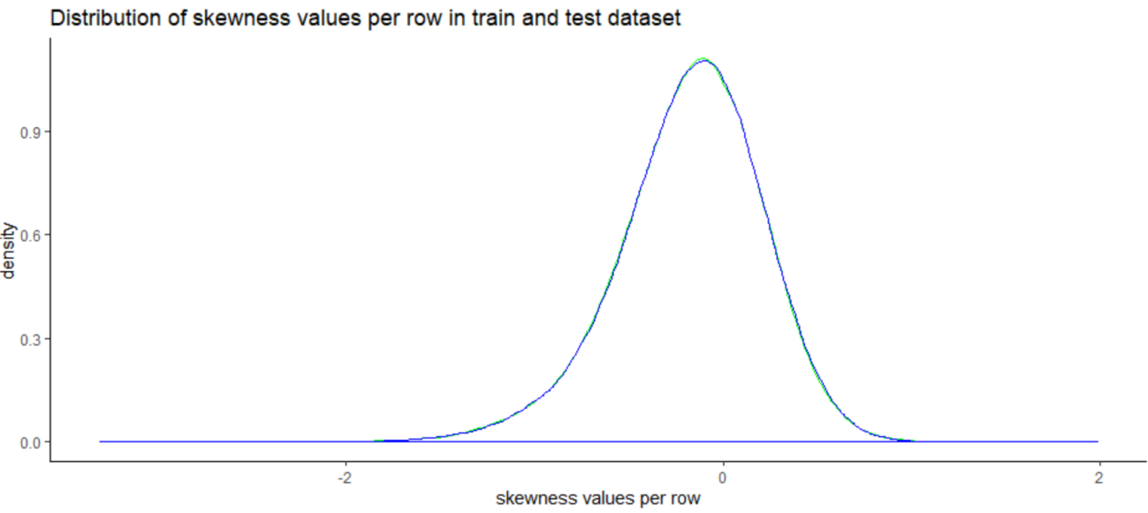

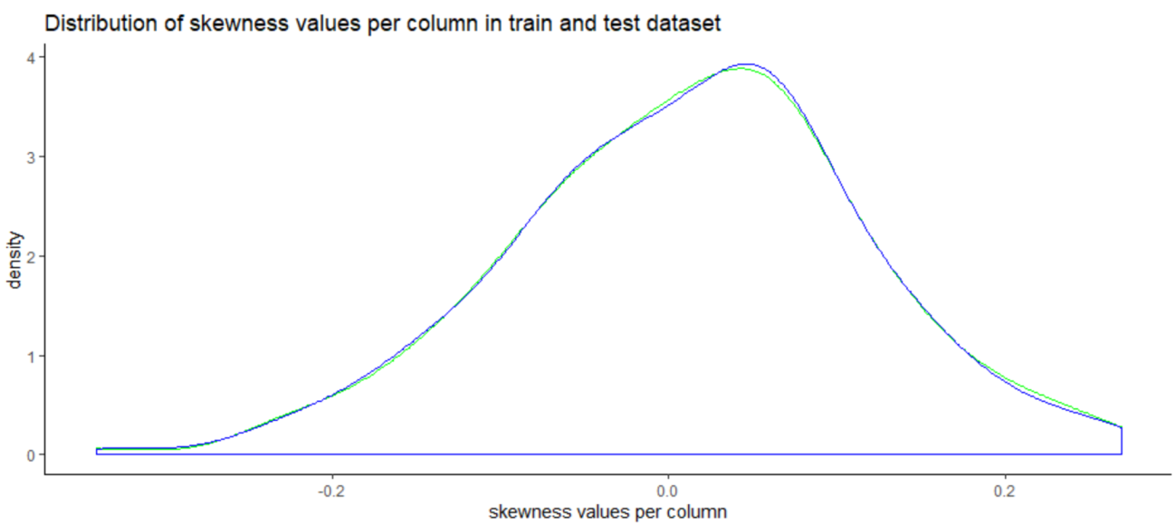 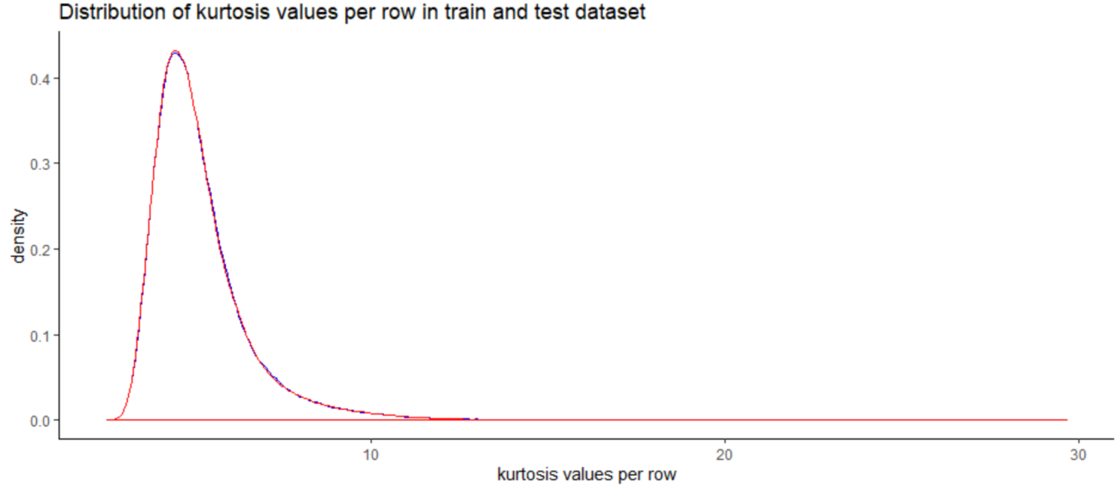 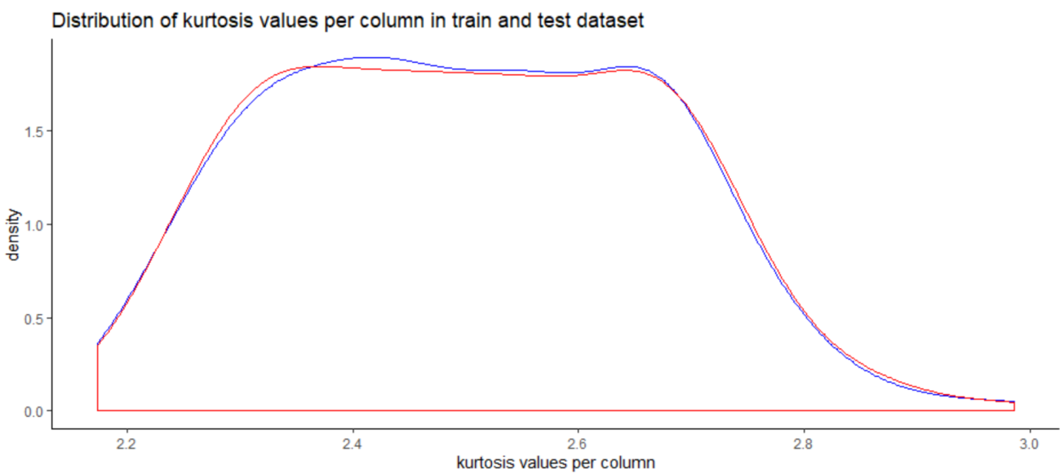

**Productionizing and Deploying Data Science Projects:**

An end-to-end data science workflow includes stages for data preparation, exploratory analysis, predictive modeling, and sharing/dissemination of the results

With any method the process is similar which involves following steps:

Business Understanding: This is the basic and first step as understanding business problem is extremely important for data scientist to move forward.

* Data Acquisition: Based on the business problem the next step is to understand and acquire the data which is needed. Identify the sources from where it is available, who are responsible to provide that data. It can come from various data sources like customer data, demographic data, third party data, weblogs, social media data, streaming data like sensor data, audio or video data. Main challenge is to decide whether data is up-to-date and clean for model consumption.
* Data Preparation: This is also called as data wrangling phase which takes almost 60% of overall project time. Collected data has to be formatted, treated for any missing values, any abnormalities or seasonality from the data and make it ready for model consumption.
* Modelling: This is the core activity of a data science project that requires writing, running and refining the programs to analyse and derive meaningful business insights from data. Often open sources tools like R, Python and commercial tools like SAS, IBM SPSS are used to create the statistical models. Various machine learning techniques are applied to data based on the business problem.
* Evaluation: There are several methods to compare the developed models and then use the best model for deployments. Typical comparison methods are AUC — area under curve, Confusion matrix, Gain/Life charts, Root Mean Squared Error etc.
* Deployment: Once the most suitable model is identified above, it is further tested with live data and then deployed into production environment.

There are further steps as well such as monitoring the live model performance, observe any degradation and new models are developed which are again compared with live model.

**Deploying Data Science Projects:**

When starting an analysis from a Python script or Jupyter notebook, there are many different approaches that can be used to transform this code into an asset that can be leveraged and consumed by many different users and roles within a data science team. Depending on the desired output, different types of data science assets can include:

Reports that can be deployed as hosted, static notebooks

Code that can be encapsulated inside of a package and shared for reusability

Dashboards and applications that can be deployed and used across an organization

Machine learning models that can be embedded in web applications or queried via RES T APIs

**Hosted, Static Notebooks:**

Jupyter Notebooks allow data scientists and developers to work in a rich, interactive environment that combines code, narrative, and visualizations with access to all of the Open Data Science functionality available in Anaconda.

Anaconda Enterprise Notebooks builds on top of the Jupyter ecosystem and provides enterprise authentication, project management, and secure collaboration to your enterprise data science workflows.

Once we have created a notebook and run an analysis, you can upload a static version of the rendered notebook to services such as Anaconda Cloud, Jupyter nbviewer, or Github. We can also publish notebooks and projects within your organization using an on-premise installation of Anaconda Repository.

These components and functionality allow end-users to view the resulting output and visualizations (both static and interactive) without requiring access to the compute resources or data sources that were used in the original analysis.

We can also typically version your notebooks within these services or a version control system, such as GIt or Subversion, so that you can track revisions and history as your data science analysis evolves. Jupyter Notebooks are stored in JSON/text format and can also be exported as Python, HTML, Markdown, reStructuredText, or PDF and shared in their desired format.

The hosted, static notebook deployment scenario only requires basic considerations around productization, since the above hosted components handle most of the availability, scalability, and security issues around deployment.

One limitation of this approach is that the hosted, rendered notebooks are not executable or interactive (aside from the interactive visualization of static data) and do not have notebook kernels or Python processes attached to them, so they need to be updated and re-uploaded manually as needed.

**Reusable Libraries and Functions:**

Data scientists typically want to take analysis code that’s been developed in a notebook during exploratory stages and move it to production to be inserted or reused in other components within a data science project.

Several approaches can be used to productionize existing code, including packaging the code in a library or wrapping it with a REST API endpoint. The latter approach is typically used when embedding the functionality in web applications and has the benefit of working across many different programming languages and web frameworks.

In the first approach, a developer can create a Python, R, or other library, build the library as a conda package, then upload the library to an on-premise instance of Anaconda Repository and share it within their organization with access control and revision history. The library can then be installed and reused by other Anaconda users and developers within an organization. The library can continue to be iteratively developed and updated while the changes and version history are tracked in Anaconda Repository.

The second approach is to create a Python script that can be deployed with an API endpoint that serves cleaned data, model predictions, or other post-processed output or results. A more detailed example of this approach is discussed later in the “Machine Learning Models with REST APIs” section.

**Dashboards:**

Dashboards have become a popular way for data scientists to deploy and share the results of their exploratory analysis in a way that can be consumed by a larger group of end-users within their organization. Dashboards are useful to better understand trends in the data during exploratory analyses, to visually summarize information when presenting project conclusions, or for reporting and monitoring business metrics on an ongoing basis.

There are a number of different ways to develop and deploy dashboards. One of the most popular development environments that our customers and users employ in their own data science workflows is Jupyter Notebooks. There is ongoing work in the Jupyter ecosystem to extend the functionality of notebooks for use cases related to dashboard construction and deployment.

Jupyter Dashboards is an incubating project within the Jupyter ecosystem that supports interactive development workflows and the easy deployment of dashboards. Jupyter Dashboards include functionality for interactively designing grid-like or report-like layouts, creating bundled notebooks and assets, and serving dashboards as web applications, all from the familiar Jupyter Notebook interface.

The components involved in Jupyter Dashboards include a drag-and-drop dashboard layout extension, a notebook-to-dashboard converter/bundler extension, and a dashboard server to host the bundled dashboards and assets.

To install, configure, and enable the components required to deploy a Jupyter Dashboard, the following Jupyter Notebook extensions and dashboard server should be installed both on the machine running the Jupyter Notebook and on a deployment server that will host the deployed dashboards.

These components can be installed manually using the documentation linked above, or they can be installed using the Jupyter Notebook functionality included with Anaconda Scale, which is available as part of Anaconda Enterprise subscriptions.

Once we have installed the necessary components and created the layout for a dashboard in a Jupyter Notebook, we can deploy the dashboard by selecting File > Deploy As > Dashboard on Jupyter Dashboards Server from the Jupyter menu. The Jupyter Dashboards documentation provides more detail on installing, configuring, and deploying dashboards.

**Complete Python and R Code**

**Python Code  
Exploratory Data Analysis**#Loading Libraries:-  
import os  
import numpy as np  
import pandas as pd  
import seaborn as sns  
import matplotlib.pyplot as plt  
import lightgbm as lgb  
import eli5  
from sklearn.model_selection import train_test_split,cross_val_predict,cross_val_score  
from sklearn.ensemble import RandomForestClassifier  
from pdpbox import pdp, get_dataset, info_plots  
from sklearn.model_selection import StratifiedKFold  
from sklearn.linear_model import LogisticRegression  
from sklearn.metrics import  
confusion_matrix,roc_auc_score,roc_curve,classification_report,roc_curve,auc  
random_state=42  
np.random.seed(random_state)  
import warnings  
warnings.filterwarnings('ignore')  
50  
os.chdir("D:/Practice-Python")  
os.getcwd()  
Importing the train dataset  
df_train=pd.read_csv("train.csv")  
pd.options.display.max_columns = None  
#Shape of the dataset  
df_train.shape  
#Summary of the dataset  
df_train.describe()  
#Target Class Count  
target_class=df_train['target'].value_counts()  
print('Count of the target class :\n',target_class)  
#Percentage of target class count  
per_target_class=df_train['target'].value_counts()/len(df_train)*100  
print('Percentage of target class count :\n',per_target_class)  
#Count plot & violin plot for target class  
fig,ax=plt.subplots(1,2,figsize=(20,5))  
sns.countplot(df_train.target.values,ax=ax[0],palette='spring')  
sns.violinplot(x=df_train.target.values,y=df_train.index.values,ax=ax[1],palette='spring')  
51  
sns.stripplot(x=df_train.target.values,y=df_train.index.values,jitter=True,color='black',lin  
ewidth=0.5,size=0.5,alpha=0.5,ax=ax[1],palette='spring')  
ax[0].set_xlabel('Target')  
ax[1].set_xlabel('Target')  
ax[1].set_ylabel('Index')  
#Distribution of train attributesdef plot_train_attribute_distribution(t0,t1,label1,label2,train_attributes):  
i=0  
sns.set_style('darkgrid')  
fig=plt.figure()  
ax=plt.subplots(10,10,figsize=(22,18))  
for attribute in train_attributes :  
i+=1  
plt.subplot(10,10,i)  
sns.distplot(t0[attribute],hist=False,label=label1)  
sns.distplot(t1[attribute],hist=False,label=label2)  
plt.legend()  
plt.xlabel('Attribute',)  
sns.set_style("ticks",{"xtick.major.size": 8, "ytick.major.size": 8})  
plt.show()  
52  
**Observing first 100 train attributes**#Corresponding to negative classt0=df_train[df_train.target.values==0]  
#Corresponding to possitive classt1=df_train[df_train.target.values==1]  
#train attributes from 2 to 102 -  
train_attributes=df_train.columns.values[2:102]  
#Plot distribution of train attributesplot_train_attribute_distribution(t0,t1,'0','1',train_attributes)  
**Observing next 100 train attributes**#train attributes from 102 to 202 -  
train_attributes=df_train.columns.values[102:202]  
#Plot distribution of train attributesplot_train_attribute_distribution(t0,t1,'0','1',train_attributes)  
#Importing the test dataset:-  
df_test=pd.read_csv("test.csv")  
#Distribution of test attributesdef plot_test_attribute_distribution(test_attributes):  
i=0  
53  
sns.set_style('darkgrid')  
fig=plt.figure()  
ax=plt.subplots(10,10,figsize=(22,18))  
for attribute in test_attributes:  
i+=1  
plt.subplot(10,10,i)  
sns.distplot(df_test[attribute],hist=False)  
plt.xlabel('Attribute',)  
sns.set_style("ticks", {"xtick.major.size": 8, "ytick.major.size": 8})  
plt.show()  
#test attribiutes from 1 to 101 -  
test_attributes=df_test.columns.values[1:101]  
#Plot distribution of test attributes -  
plot_test_attribute_distribution(test_attributes)  
#test attributes from 101 to 202-  
test_attributes=df_test.columns.values[101:202]  
#Plot the distribution of test attributesplot_test_attribute_distribution(test_attributes)  
#Distribution of Mean Values per column in train & test dataset:-  
plt.figure(figsize=(16,8))  
54  
#Train attributestrain_attributes=df_train.columns.values[2:202]  
#Test attributestest_attributes=df_test.columns.values[1:201]  
#Distribution plot for mean values per column in train attributes:  
sns.distplot(df_train[train_attributes].mean(axis=0),color='red',kde=True,bins=150,label=  
'train')  
#Distribution plot for mean values per column in test attributes:  
sns.distplot(df_test[test_attributes].mean(axis=0),color='blue',kde=True,bins=150,label='t  
est')  
plt.title('Distribution of Mean Values per column in train & test dataset')  
plt.legend()  
plt.show()  
#Distribution of Mean Values per column in train & test dataset:-  
plt.figure(figsize=(16,8))  
#Distribution plot for mean values per rows in train attributes:  
sns.distplot(df_train[train_attributes].mean(axis=1),color='red',kde=True,bins=150,label=  
'train')  
#Distribution plot for mean values per rows in test attributes:  
55  
sns.distplot(df_test[test_attributes].mean(axis=1),color='blue',kde=True,bins=150,label='t  
est')  
plt.title('Distribution of Mean Values per row in train & test dataset')  
plt.legend()  
plt.show()  
#Distribution of S.D Values per column in train & test dataset:-  
plt.figure(figsize=(16,8))  
#Train attributestrain_attributes=df_train.columns.values[2:202]  
#Test attributestest_attributes=df_test.columns.values[1:201]  
#Distribution plot for S.D values per column in train attributes:  
sns.distplot(df_train[train_attributes].std(axis=0),color='blue',kde=True,bins=150,label='t  
rain')  
#Distribution plot for S.D values per column in test attributes:  
sns.distplot(df_test[test_attributes].std(axis=0),color='green',kde=True,bins=150,label='te  
st')  
plt.title('Distribution of S.D Values per column in train & test dataset')  
plt.legend()  
plt.show()  
56  
#Distribution of S.D Values per column in train & test dataset:-  
plt.figure(figsize=(16,8))  
#Distribution plot for S.D values per rows in train attributes:  
sns.distplot(df_train[train_attributes].std(axis=1),color='blue',kde=True,bins=150,label='t  
rain')  
#Distribution plot for S.D values per rows in test attributes:  
sns.distplot(df_test[test_attributes].std(axis=1),color='green',kde=True,bins=150,label='te  
st')  
plt.title('Distribution of S.D Values per row in train & test dataset')  
plt.legend()  
plt.show()  
#Distribution of skew Values per column in train & test dataset:-  
plt.figure(figsize=(16,8))  
#Train attributestrain_attributes=df_train.columns.values[2:202]  
#Test attributestest_attributes=df_test.columns.values[1:201]  
#Distribution plot for skew values per column in train attributes:  
sns.distplot(df_train[train_attributes].skew(axis=0),color='red',kde=True,bins=150,label='  
train')  
57  
#Distribution plot for skew values per column in test attributes:  
sns.distplot(df_test[test_attributes].skew(axis=0),color='green',kde=True,bins=150,label=  
'test')  
plt.title('Distribution of skewness Values per column in train & test dataset')  
plt.legend()  
plt.show()  
#Distribution of skew Values per column in train & test dataset:-  
plt.figure(figsize=(16,8))  
#Distribution plot for skew values per rows in train attributes:  
sns.distplot(df_train[train_attributes].skew(axis=1),color='red',kde=True,bins=150,label='  
train')  
#Distribution plot for skew values per rows in test attributes:  
sns.distplot(df_test[test_attributes].skew(axis=1),color='green',kde=True,bins=150,label=  
'test')  
plt.title('Distribution of skewness Values per row in train & test dataset')  
plt.legend()  
plt.show()  
#Distribution of kurtosis Values per column in train & test dataset:-  
plt.figure(figsize=(16,8))  
58  
#Train attributestrain_attributes=df_train.columns.values[2:202]  
#Test attributestest_attributes=df_test.columns.values[1:201]  
#Distribution plot for kurtosis values per column in train attributes:  
sns.distplot(df_train[train_attributes].kurtosis(axis=0),color='red',kde=True,bins=150,lab  
el='train')  
#Distribution plot for kurtosis values per column in test attributes:  
sns.distplot(df_test[test_attributes].kurtosis(axis=0),color='blue',kde=True,bins=150,label  
='test')  
plt.title('Distribution of kurtosis Values per column in train & test dataset')  
plt.legend()  
plt.show()  
#Distribution of kurtosis Values per column in train & test dataset:-  
plt.figure(figsize=(16,8))  
#Distribution plot for kurtosis values per rows in train attributes:  
sns.distplot(df_train[train_attributes].kurtosis(axis=1),color='red',kde=True,bins=150,lab  
el='train')  
59  
#Distribution plot for kurtosis values per rows in test attributes:  
sns.distplot(df_test[test_attributes].kurtosis(axis=1),color='green',kde=True,bins=150,lab  
el='test')  
plt.title('Distribution of kurtosis Values per row in train & test dataset')  
plt.legend()  
plt.show()  
#Finding the missing values in train & test dataset:-  
train_missing=df_train.isnull().sum().sum()  
test_missing=df_test.isnull().sum().sum()  
print('Missing values in train data:',train_missing)  
print('Missing values in test data:',test_missing)  
#Correlation in train attiributestrain_attributes=df_train.columns.values[2:202]  
train_correlation=df_train[train_attributes].corr().abs().unstack().sort_values(kind='quick  
sort').reset_index()  
train_correlation=train_correlation[train_correlation['level_0']!=train_correlation['level_1  
']]  
print(train_correlation.head(10))  
print(train_correlation.tail(10))  
#Correlation in test attiributestest_attributes=df_test.columns.values[1:201]  
test_correlation=df_test[train_attributes].corr().abs().unstack().sort_values(kind='quickso  
rt').reset_index()  
60  
test_correlation=test_correlation[test_correlation['level_0']!=test_correlation['level_1']]  
print(test_correlation.head(10))  
print(test_correlation.tail(10))  
**Correlation plot for train and test data:**train_correlation=df_train[train_attributes].corr()  
train_correlation=train_correlation.values.flatten()  
train_correlation=train_correlation[train_correlation!=1]  
test_correlation=df_test[test_attributes].corr()  
test_correlation=test_correlation.values.flatten()  
test_correlation=test_correlation[test_correlation!=1]  
plt.figure(figsize=(20,5))  
sns.distplot(train_correlation,color="blue",label="train")  
sns.distplot(test_correlation,color="red",label="test")  
plt.xlabel("Correlation values found in train & test data")  
plt.ylabel("Density")  
plt.title ("Correlation values in train & test data")  
plt.legend()  
**Feature Engineering :-** Performing feature engineering by using-  
- Permutation Importance  
- Partial dependence plots  
#Training & testing data:  
61  
X=df_train.drop(columns=['ID_code','target'],axis=1)  
test=df_test.drop(columns=['ID_code'],axis=1)  
y=df_train['target']  
**Building a simple model to find the features which are more important:**#Split the train data:-  
X_train,X_test,y_train,y_test=train_test_split(X,y,random_state=42)  
**Random Forest Classifier:-**rf_model=RandomForestClassifier(n_estimators=10,random_state=42)  
#fitting the model:-  
rf_model.fit(X_test,y_test)  
#Permutation Importance:-  
from eli5.sklearn import PermutationImportance  
perm_imp=PermutationImportance(rf_model,random_state=42)  
#fitting the model:-  
perm_imp.fit(X_test,y_test)  
#Important Features:-  
eli5.show_weights(perm_imp,feature_names=X_test.columns.tolist(),top=200)  
#Calculation of partial dependence plots on random forest:-  
#we are observing impact of main features which are discovered in previous section by  
using PDP Plot.  
62  
features=[v for v in X_test.columns if v not in ['ID_code','target']]  
pdp_data=pdp.pdp_isolate(rf_model, dataset=X_test, model_features=features,  
feature='var_6')  
#Plot feature for var_6:-  
pdp.pdp_plot(pdp_data,'var_6')  
plt.show()  
#Plot feature for var_53:-  
pdp_data=pdp.pdp_isolate(rf_model, dataset=X_test, model_features=features,  
feature='var_53')  
pdp.pdp_plot(pdp_data,'var_53')  
plt.show()  
**Logistic Regression Model:-**#Spliting the data via Sratified KFold Cross Validator:-  
#Training Data:  
X=df_train.drop(['ID_code','target'],axis=1)  
Y=df_train['target']  
#Stratified KFold Cross Validator:-  
skf=StratifiedKFold(n_splits=5, random_state=42, shuffle=True)  
for train_index, valid_index in skf.split(X,Y):  
X_train, X_valid = X.iloc[train_index], X.iloc[valid_index]  
63  
y_train, y_valid = Y.iloc[train_index], Y.iloc[valid_index]  
print('Shape of X_train :',X_train.shape)  
print('Shape of X_valid :',X_valid.shape)  
print('Shape of y_train :',y_train.shape)  
print('Shape of y_valid :',y_valid.shape)  
lr_model=LogisticRegression(random_state=42)  
#fitting the modellr_model.fit(X_train,y_train)  
#Accuracy of modellr_score=lr_model.score(X_train,y_train)  
print('Accuracy of lr_model :',lr_score)  
#Cross validation prediction of lr_modelcv_predict=cross_val_predict(lr_model,X_valid,y_valid,cv=5)  
#Cross validation scorecv_score=cross_val_score(lr_model,X_valid,y_valid,cv=5)  
print('cross val score :',np.average(cv_score))  
#Confusion matrix:-  
cm=confusion_matrix(y_valid,cv_predict)  
cm=pd.crosstab(y_valid,cv_predict)  
cm  
#ROC_AUC SCORE:-  
64  
roc_score=roc_auc_score(y_valid,cv_predict)  
print('ROC Score:',roc_score)  
#ROC_AUC_Curve:-  
plt.figure()  
false_positive_rate,recall,thresholds=roc_curve(y_valid,cv_predict)  
roc_auc=auc(false_positive_rate,recall)  
plt.title('Reciver Operating Characteristics(ROC)')  
plt.plot(false_positive_rate,recall,'b',label='ROC(area=%0.3f)' %roc_auc)  
plt.legend()  
plt.plot([0,1],[0,1],'r--')  
plt.xlim([0.0,1.0])  
plt.ylim([0.0,1.0])  
plt.ylabel('Recall(True Positive Rate)')  
plt.xlabel('False Positive Rate')  
plt.show()  
print('AUC:',roc_auc)  
#Classification report:-  
classification_scores=classification_report(y_valid,cv_predict)  
print(classification_scores)  
#Model performance on test data:-  
X_test=df_test.drop(['ID_code'],axis=1)  
lr_pred=lr_model.predict(X_test)  
print(lr_pred)  
65  
from imblearn.over_sampling import SMOTE  
#SMOTE:-  
sm = SMOTE(random_state=42, ratio=1.0)  
#Generating synthetic data points  
X_smote,y_smote=sm.fit_sample(X_train,y_train)  
X_smote_v,y_smote_v=sm.fit_sample(X_valid,y_valid)  
#Logistic regression model for SMOTE:-  
smote=LogisticRegression(random_state=42)  
#fitting the smote model:-  
smote.fit(X_smote,y_smote)  
#Accuracy of the model:-  
smote_score=smote.score(X_smote,y_smote)  
print('Accuracy of the smote_model :',smote_score)  
#Cross validation prediction for SMOTE:-  
cv_pred=cross_val_predict(smote,X_smote_v,y_smote_v,cv=5)  
#Cross validation score:-  
cv_score=cross_val_score(smote,X_smote_v,y_smote_v,cv=5)  
print('Cross validation score :',np.average(cv_score))  
#Confusion matrix:-  
cm=confusion_matrix(y_smote_v,cv_pred)  
cm=pd.crosstab(y_smote_v,cv_pred)  
66  
#ROC_AUC SCORE:-  
roc_score=roc_auc_score(y_smote_v,cv_pred)  
print('ROC score:',roc_score)  
#ROC_AUC Curve:-  
plt.figure()  
false_positive_rate,recall,thresholds=roc_curve(y_smote_v,cv_pred)  
roc_auc=auc(false_positive_rate,recall)  
plt.title('Reciver Operating Characteristics(ROC)')  
plt.plot(false_positive_rate,recall,'b',label='ROC(area=%0.3f)' %roc_auc)  
plt.legend()  
plt.plot([0,1],[0,1],'r--')  
plt.xlim([0.0,1.0])  
plt.ylim([0.0,1.0])  
plt.ylabel('Recall(True Positive Rate)')  
plt.xlabel('False Positive Rate')  
plt.show()  
print('AUC:',roc_auc)  
#Classification Report:-  
scores=classification_report(y_smote_v,cv_pred)  
print(scores)  
#Predicting the modelX_test=df_test.drop(['ID_code'],axis=1)  
smote_pred=smote.predict(X_test)  
print(smote_pred)  
67  
LightGBM:-  
#Training datalgb_train=lgb.Dataset(X_train,label=y_train)  
#Validation datalgb_valid=lgb.Dataset(X_valid,label=y_valid)  
#Selecting best hyperparameters by tuning of different parameters:-  
params={'boosting_type': 'gbdt',  
'max_depth' : -1, #no limit for max_depth if <0  
'objective': 'binary',  
'boost_from_average':False,  
'nthread': 20,  
'metric':'auc',  
'num_leaves': 50,  
'learning_rate': 0.01,  
'max_bin': 100, #default 255  
'subsample_for_bin': 100,  
'subsample': 1,  
'subsample_freq': 1,  
'colsample_bytree': 0.8,  
'bagging_fraction':0.5,  
'bagging_freq':5,  
'feature_fraction':0.08,  
'min_split_gain': 0.45, #>0  
68  
'min_child_weight': 1,  
'min_child_samples': 5,  
'is_unbalance':True,  
}  
#Training lgbm model:-  
num_rounds=10000  
lgbm=  
lgb.train(params,lgb_train,num_rounds,valid_sets=[lgb_train,lgb_valid],verbose_eval=10  
00,early_stopping_rounds = 5000)  
lgbm  
**LGBM model performance on test data:-**X_test=df_test.drop(['ID_code'],axis=1)  
#Predict the model:-  
#probability predictions  
lgbm_predict_prob=lgbm.predict(X_test,random_state=42,num_iteration=lgbm.best_iter  
ation)  
#Convert to binary output 1 or 0  
lgbm_predict=np.where(lgbm_predict_prob>=0.5,1,0)  
print(lgbm_predict_prob)  
print(lgbm_predict)  
Plotting important features:-  
lgb.plot_importance(lgbm,max_num_features=50,importance_type="split",figsize=(20,5  
0))  
69  
#Final submission:-  
df_sub=pd.DataFrame({'ID_code':df_test['ID_code'].values})  
df_sub['lgbm_predict_prob']=lgbm_predict_prob  
df_sub['lgbm_predict']=lgbm_predict  
df_sub.to_csv('submission.csv',index=False)  
df_sub.head()  
70

**R Code:-  
#Loading Libraries:-**library(tidyverse)  
library(moments)  
library(DataExplorer)  
library(caret)  
library(Matrix)  
library(pdp)  
library(mlbench)  
library(caTools)  
library(randomForest)  
library(glmnet)  
library(mlr)  
library(vita)  
library(rBayesianOptimization)  
library(lightgbm)  
library(pROC)  
library(DMwR)  
library(ROSE)  
library(yardstick)  
**#Setting Directory:-**setwd("D:/Practice_R")  
**#Importing the training Data:-**df_train=read.csv("train.csv")  
71  
head(df_train)  
#Dimension of the train data:-  
dim(df_train)  
#Summary of the train dataset:-  
str(df_train)  
#Typecasting the target variable:-  
df_train$target=as.factor(df_train$target)  
#Target class count in train data:-  
table(df_train$target)  
#Percentage count of taregt class in train data:-  
table(df_train$target)/length(df_train$target)*100  
#Bar plot for count of target classes in train data:-  
plot1=ggplot(df_train,aes(target))+theme_bw()+geom_bar(stat='count',fill='lightgreen')  
#Violin with jitter plots for target classes  
plot2=ggplot(df_train,aes(x=target,y=1:nrow(df_train)))+theme_bw()+geom_violin(fill='  
lightblue')+  
facet_grid(df_train$target)+geom_jitter(width=0.02)+labs(y='Index')  
grid.arrange(plot1,plot2, ncol=2)  
#Observation:- We are having a unbalanced data, where 90% of the data is no. of  
customers who will not make a transaction & 10 % of the data are those who will make a  
transaction.  
72  
#Distribution of train attributes from 3 to 102:-  
for (var in names(df_train)[c(3:102)]){  
target<-df_train$target  
plot<-ggplot(df_train, aes(df_train[[var]],fill=target)) +  
geom_density(kernel='gaussian') + ggtitle(var)+theme_classic()  
print(plot)  
}  
#Distribution of train attributes from 103 to 202:-  
for (var in names(df_train)[c(103:202)]){  
target<-df_train$target  
plot<-ggplot(df_train, aes(df_train[[var]],fill=target)) +  
geom_density(kernel='gaussian') + ggtitle(var)+theme_classic()  
print(plot)  
}  
#Importing the test data:-  
df_test=read.csv("test.csv")  
head(df_test)  
#Dimension of test dataset:-  
dim(df_test)  
#Distribution of test attributes from 2 to 101:-  
plot_density(df_test[,c(2:101)],ggtheme = theme_classic(),geom_density_args =  
list(color='red'))  
73  
#Distribution of test attributes from 102 to 201:-  
plot_density(df_test[,c(102:201)],ggtheme = theme_classic(),geom_density_args =  
list(color='red'))  
**#Mean value per rows and columns in train & test dataset:-**#Applying the function to find mean values per row in train and test data.  
train_mean<-apply(df_train[,-c(1,2)],MARGIN=1,FUN=mean)  
test_mean<-apply(df_test[,-c(1)],MARGIN=1,FUN=mean)  
ggplot()+  
#Distribution of mean values per row in train data  
geom_density(data=df_train[,-  
c(1,2)],aes(x=train_mean),kernel='gaussian',show.legend=TRUE,color='blue')+theme_cla  
ssic()+  
#Distribution of mean values per row in test data  
geom_density(data=df_test[,-  
c(1)],aes(x=test_mean),kernel='gaussian',show.legend=TRUE,color='green')+  
labs(x='mean values per row',title="Distribution of mean values per row in train and test  
dataset")  
#Applying the function to find mean values per column in train and test data.  
train_mean<-apply(df_train[,-c(1,2)],MARGIN=2,FUN=mean)  
test_mean<-apply(df_test[,-c(1)],MARGIN=2,FUN=mean)  
ggplot()+  
#Distribution of mean values per column in train data  
geom_density(aes(x=train_mean),kernel='gaussian',show.legend=TRUE,color='blue')+th  
eme_classic()+  
74  
#Distribution of mean values per column in test data  
geom_density(aes(x=test_mean),kernel='gaussian',show.legend=TRUE,color='green')+  
labs(x='mean values per column',title="Distribution of mean values per column in train  
and test dataset")  
**Standard Deviation Distribution:-**#Applying the function to find standard deviation values per row in train and test data.  
train_sd<-apply(df_train[,-c(1,2)],MARGIN=1,FUN=sd)  
test_sd<-apply(df_test[,-c(1)],MARGIN=1,FUN=sd)  
ggplot()+  
#Distribution of sd values per row in train data  
geom_density(data=df_train[,-  
c(1,2)],aes(x=train_sd),kernel='gaussian',show.legend=TRUE,color='red')+theme_classic  
()+  
#Distribution of sd values per row in test data  
geom_density(data=df_test[,-  
c(1)],aes(x=test_sd),kernel='gaussian',show.legend=TRUE,color='blue')+  
labs(x='sd values per row',title="Distribution of sd values per row in train and test  
dataset")  
#Applying the function to find sd values per column in train and test data.  
train_sd<-apply(df_train[,-c(1,2)],MARGIN=2,FUN=sd)  
test_sd<-apply(df_test[,-c(1)],MARGIN=2,FUN=sd)  
ggplot()+  
#Distribution of sd values per column in train data  
geom_density(aes(x=train_sd),kernel='gaussian',show.legend=TRUE,color='red')+theme  
_classic()+  
75  
#Distribution of sd values per column in test data  
geom_density(aes(x=test_sd),kernel='gaussian',show.legend=TRUE,color='blue')+  
labs(x='sd values per column',title="Distribution of std values per column in train and  
test dataset")  
**Skewness Distribution**:-  
#Applying the function to find skewness values per row in train and test data.  
train_skew<-apply(df_train[,-c(1,2)],MARGIN=1,FUN=skewness)  
test_skew<-apply(df_test[,-c(1)],MARGIN=1,FUN=skewness)  
ggplot()+  
#Distribution of skewness values per row in train data  
geom_density(aes(x=train_skew),kernel='gaussian',show.legend=TRUE,color='green')+t  
heme_classic()+  
#Distribution of skewness values per column in test data  
geom_density(aes(x=test_skew),kernel='gaussian',show.legend=TRUE,color='blue')+  
labs(x='skewness values per row',title="Distribution of skewness values per row in train  
and test dataset")  
#Applying the function to find skewness values per column in train and test data.  
train_skew<-apply(df_train[,-c(1,2)],MARGIN=2,FUN=skewness)  
test_skew<-apply(df_test[,-c(1)],MARGIN=2,FUN=skewness)  
ggplot()+  
#Distribution of skewness values per column in train data  
geom_density(aes(x=train_skew),kernel='gaussian',show.legend=TRUE,color='green')+t  
heme_classic()+  
#Distribution of skewness values per column in test data  
76  
geom_density(aes(x=test_skew),kernel='gaussian',show.legend=TRUE,color='blue')+  
labs(x='skewness values per column',title="Distribution of skewness values per column  
in train and test dataset")  
**Kurtosis Distribution**:-  
#Applying the function to find kurtosis values per row in train and test data.  
train_kurtosis<-apply(df_train[,-c(1,2)],MARGIN=1,FUN=kurtosis)  
test_kurtosis<-apply(df_test[,-c(1)],MARGIN=1,FUN=kurtosis)  
ggplot()+  
#Distribution of kurtosis values per row in train data  
geom_density(aes(x=train_kurtosis),kernel='gaussian',show.legend=TRUE,color='blue')+  
theme_classic()+  
#Distribution of kurtosis values per row in test data  
geom_density(aes(x=test_kurtosis),kernel='gaussian',show.legend=TRUE,color='red')+  
labs(x='kurtosis values per row',title="Distribution of kurtosis values per row in train  
and test dataset")  
#Applying the function to find kurtosis values per column in train and test data.  
train_kurtosis<-apply(df_train[,-c(1,2)],MARGIN=2,FUN=kurtosis)  
test_kurtosis<-apply(df_test[,-c(1)],MARGIN=2,FUN=kurtosis)  
ggplot()+  
#Distribution of kurtosis values per column in train data  
geom_density(aes(x=train_kurtosis),kernel='gaussian',show.legend=TRUE,color='blue')+  
theme_classic()+  
#Distribution of kurtosis values per column in test data  
geom_density(aes(x=test_kurtosis),kernel='gaussian',show.legend=TRUE,color='red')+  
labs(x='kurtosis values per column',title="Distribution of kurtosis values per column in  
train and test dataset")  
77  
#**Missing Value Analysis**:-  
#Finding the missing values in train data  
missing_val<-data.frame(missing_val=apply(df_train,2,function(x){sum(is.na(x))}))  
missing_val<-sum(missing_val)  
missing_val  
#Finding the missing values in test data  
missing_val<-data.frame(missing_val=apply(df_test,2,function(x){sum(is.na(x))}))  
missing_val<-sum(missing_val)  
missing_val  
#Correlations in train data:-  
#convert factor to int  
df_train$target<-as.numeric(df_train$target)  
train_correlation<-cor(df_train[,c(2:202)])  
train_correlation  
#Observation:- We can observe that correlation between train attributes is very small.  
#Correlations in test data  
test_correlation<-cor(df_test[,c(2:201)])  
test_correlation  
#Observation:- We can observe that correlation between test attributes is very small.  
78  
**#Feature Enginnering**:- Performing some feature engineering on datasets:-  
#Variable Importance:-Variable importance is used to see top features in dataset based on  
mean decreases gini .  
#Building a simple model to find features which are imp:-  
#Split the training data using simple random sampling  
train_index<-sample(1:nrow(df_train),0.75*nrow(df_train))  
#train data  
train_data<-df_train[train_index,]  
#validation data  
valid_data<-df_train[-train_index,]  
#dimension of train and validation data  
dim(train_data)  
dim(valid_data)  
#Random forest classifier:-  
#Training the Random forest classifier  
set.seed(2732)  
#convert to int to factor  
train_data$target<-as.factor(train_data$target)  
#setting the mtry  
mtry<-floor(sqrt(200))  
#setting the tunegrid  
tuneGrid<-expand.grid(.mtry=mtry)  
79  
#fitting the ranndom forest  
rf<-randomForest(target~.,train_data[,-c(1)],mtry=mtry,ntree=10,importance=TRUE)  
#Feature importance by random forest-  
#Variable importance  
VarImp<-importance(rf,type=2)  
VarImp  
#Observation:-We can observed that the top important features are var_12, var_26,  
var_22,v var_174, var_198 and so on based on Mean decrease gini.  
#Partial dependence plots:-PDP gives a graphical depiction of marginal effect of a  
variable on the class probability or classification. It shows how a feature effects  
predictions.  
#Calculation of partial dependence plots on random forest:-  
#we are observing impact of main features which are discovered in previous section by  
using PDP Plot.  
#We will plot "var_13"  
par.var_13 <- partial(rf, pred.var = c("var_13"), chull = TRUE)  
plot.var_13 <- autoplot(par.var_13, contour = TRUE)  
plot.var_13  
#We will plot "var_6"  
par.var_6 <- partial(rf, pred.var = c("var_6"), chull = TRUE)  
plot.var_6 <- autoplot(par.var_6, contour = TRUE)  
plot.var_6  
80  
**#Handling of imbalanced data**- Now we are going to explore 5 different approaches for  
dealing with imbalanced datasets.  
#Change the performance metric  
#Oversample minority class  
#Undersample majority class  
#ROSE  
#LightGBM  
#Logistic Regression Model:-  
#Split the data using simple random sampling:-  
set.seed(689)  
train.index<-sample(1:nrow(df_train),0.8*nrow(df_train))  
#train data  
train.data<-df_train[train.index,]  
#validation data  
valid.data<-df_train[-train.index,]  
#dimension of train data  
dim(train.data)  
#dimension of validation data  
dim(valid.data)  
#target classes in train data  
table(train.data$target)  
#target classes in validation data  
table(valid.data$target)  
81  
#Training and validation dataset  
#Training dataset  
X_t<-as.matrix(train.data[,-c(1,2)])  
y_t<-as.matrix(train.data$target)  
#validation dataset  
X_v<-as.matrix(valid.data[,-c(1,2)])  
y_v<-as.matrix(valid.data$target)  
#test dataset  
test<-as.matrix(df_test[,-c(1)])  
#Logistic regression model  
set.seed(667) # to reproduce results  
lr_model <-glmnet(X_t,y_t, family = "binomial")  
summary(lr_model)  
#Cross validation prediction  
set.seed(8909)  
cv_lr <- cv.glmnet(X_t,y_t,family = "binomial", type.measure = "class")  
cv_lr  
#Plotting the missclassification error vs log(lambda) where lambda is regularization  
parameter  
#Minimum lambda  
cv_lr$lambda.min  
#plot the auc score vs log(lambda)  
plot(cv_lr)  
82  
#Observation:-We can observed that miss classification error increases as increasing the  
log(Lambda).  
#Model performance on validation dataset  
set.seed(5363)  
cv_predict.lr<-predict(cv_lr,X_v,s = "lambda.min", type = "class")  
cv_predict.lr  
#Observation:-Accuracy of the model is not the best metric to use when evaluating the  
imbalanced datasets as it may be misleading. So, we are going to change the performance  
metric.  
#Confusion Matrix:-  
set.seed(689)  
#actual target variable  
target<-valid.data$target  
#convert to factor  
target<-as.factor(target)  
#predicted target variable  
#convert to factor  
cv_predict.lr<-as.factor(cv_predict.lr)  
confusionMatrix(data=cv_predict.lr,reference=target)  
#Reciever operating characteristics(ROC)-Area under curve(AUC) score and curve:-  
#ROC_AUC score and curve  
set.seed(892)  
cv_predict.lr<-as.numeric(cv_predict.lr)  
83  
roc(data=valid.data[,-  
c(1,2)],response=target,predictor=cv_predict.lr,auc=TRUE,plot=TRUE)  
**#Oversample Minority Class:-**#-Adding more copies of minority class.  
#-It cab be a good option we dont have that much large data to work.  
#-Drawback of this process is we are adding info. That can lead to overfitting or poor  
performance on test data.  
**#Undersample Mojorityclass**:-  
#-Removing some copies of majority class.  
#-It can be a good option if we have very large amount of data say in millions to work.  
#-Drawback of this process is we are removing some valuable info. that can leads to  
underfitting & poor performance on test data.  
#Both Oversampling and undersampling techniques have some drawbacks. So, we are  
not going to use this models for this problem and also we will use other best algorithms.  
**#Random Oversampling Examples(ROSE)-** It creates a sample of synthetic data by  
enlarging the features space of minority and majority class examples.  
#Random Oversampling Examples(ROSE)  
set.seed(699)  
train.rose <- ROSE(target~., data =train.data[,-c(1)],seed=32)$data  
#target classes in balanced train data  
table(train.rose$target)  
valid.rose <- ROSE(target~., data =valid.data[,-c(1)],seed=42)$data  
#target classes in balanced valid data  
table(valid.rose$target)  
84  
#Logistic regression model  
set.seed(462)  
lr_rose <-glmnet(as.matrix(train.rose),as.matrix(train.rose$target), family = "binomial")  
summary(lr_rose)  
#Cross validation prediction  
set.seed(473)  
cv_rose = cv.glmnet(as.matrix(valid.rose),as.matrix(valid.rose$target),family =  
"binomial", type.measure = "class")  
cv_rose  
#Plotting the missclassification error vs log(lambda) where lambda is regularization  
parameter:-  
#Minimum lambda  
cv_rose$lambda.min  
#plot the auc score vs log(lambda)  
plot(cv_rose)  
#Model performance on validation dataset  
set.seed(442)  
cv_predict.rose<-predict(cv_rose,as.matrix(valid.rose),s = "lambda.min", type = "class")  
cv_predict.rose  
#Confusion matrix  
set.seed(478)  
85  
#actual target variable  
target<-valid.rose$target  
#convert to factor  
target<-as.factor(target)  
#predicted target variable  
#convert to factor  
cv_predict.rose<-as.factor(cv_predict.rose)  
#Confusion matrix  
confusionMatrix(data=cv_predict.rose,reference=target)  
#ROC_AUC score and curve  
set.seed(843)  
#convert to numeric  
cv_predict.rose<-as.numeric(cv_predict.rose)  
roc(data=valid.rose[,-  
c(1,2)],response=target,predictor=cv_predict.rose,auc=TRUE,plot=TRUE)  
#LightGBM:-LightGBM is a gradient boosting framework that uses tree based learning  
algorithms. We are going to use LightGBM model.  
#Training and validation dataset  
#Convert data frame to matrix  
set.seed(5432)  
X_train<-as.matrix(train.data[,-c(1,2)])  
y_train<-as.matrix(train.data$target)  
X_valid<-as.matrix(valid.data[,-c(1,2)])  
86  
y_valid<-as.matrix(valid.data$target)  
test_data<-as.matrix(df_test[,-c(1)])  
#training data  
lgb.train <- lgb.Dataset(data=X_train, label=y_train)  
#Validation data  
lgb.valid <- lgb.Dataset(data=X_valid,label=y_valid)  
#Choosing best hyperparameters  
#Selecting best hyperparameters  
set.seed(653)  
lgb.grid = list(objective = "binary",  
metric = "auc",  
boost='gbdt',  
max_depth=-1,  
boost_from_average='false',  
min_sum_hessian_in_leaf = 12,  
feature_fraction = 0.05,  
bagging_fraction = 0.45,  
bagging_freq = 5,  
learning_rate=0.02,  
tree_learner='serial',  
num_leaves=20,  
num_threads=5,  
min_data_in_bin=150,  
87  
min_gain_to_split = 30,  
min_data_in_leaf = 90,  
verbosity=-1,  
is_unbalance = TRUE)  
#Training the lgbm model  
set.seed(7663)  
lgbm.model <- lgb.train(params = lgb.grid, data = lgb.train, nrounds =10000,eval_freq  
=1000,  
valids=list(val1=lgb.train,val2=lgb.valid),early_stopping_rounds = 5000)  
#lgbm model performance on test data  
set.seed(6532)  
lgbm_pred_prob <- predict(lgbm.model,test_data)  
print(lgbm_pred_prob)  
#Convert to binary output (1 and 0) with threshold 0.5  
lgbm_pred<-ifelse(lgbm_pred_prob>0.5,1,0)  
print(lgbm_pred)  
#Let us plot the important features  
set.seed(6521)  
#feature importance plot  
tree_imp <- lgb.importance(lgbm.model, percentage = TRUE)  
lgb.plot.importance(tree_imp, top_n = 50, measure = "Frequency", left_margin = 10)  
88  
#We tried model with logistic regression,ROSE and lightgbm. But,lightgbm is  
performing well on imbalanced data compared to other models based on scores of  
roc_auc_score.  
#Final submission  
sub_df<-  
data.frame(ID_code=df_test$ID_code,lgb_predict_prob=lgbm_pred_prob,lgb_predict=lg  
bm_pred)  
write.csv(sub_df,'submission-R.CSV',row.names=F)  
head(sub_df)